

Department of Information and Communication Technology

Faculty of Technology University of Ruhuna

**Tool Management System**

**Software Requirement Specification**

Group Project (ICT3183)

Project ID: **GP-2024-02**

Submitted by:

1. TG/2020/688 – J.M.N.A. Senevirathne
2. TG/2020/717 – W.A.I. Ganga
3. TG/2020/737 – I.A.N.M. Anusari
4. TG/2020/738 – N.G. Sansala

Submitted to:

…………………………..

Name of the supervisor:

Ms. Malsha Prabudhdhi

Date of submission

25.02.2024

**Table of Contents**

**1.** **Introduction** 3

**1.1** **Purpose** 3

**1.2** **Document Conventions** 4

**1.3** **Intended Audience and Reading Suggestions** 4

**1.4** **Product Scope** 5

1.5 **References** 5

**2.** **Overall Description** 6

**2.1** **Product Perspective** 6

**2.2** **Product Functions** 7

**2.3** **User Classes and Characteristics** 8

**2.4** **Operating Environment** 10

**2.5** **Design and Implementation Constraints** 11

**2.6** **Project Documentation** 11

**2.7** **User Documentation** 11

**2.8** **Assumptions and Dependencies** 11

**3.** **External Interface Requirements** 12

**3.1** **User Interfaces for the Web application** 12

**3.2** **Hardware Interfaces** 29

**3.3** **Software Interfaces** 29

**3.4** **Communication Interfaces** 29

**4.** **System Features** 30

**4.1** **Use Case Diagram** 30

**4.2** **ER Diagram** 31

**4.3** **Data Flow Diagram** 32

**4.4 Test Case Description** 33

**5.** **Other Nonfunctional Requirements** 89

**a.** **Performance Requirements** 89

**b.** **Safety Requirements** 89

**c.** **Security Requirements** 90

**d.** **Software Quality Attributes** 90

**e.** **Business Rules** 91

# 1. Introduction

The most famous cranes companies have challenges to manage their tool stores. They want to deliver tools to various projects, according to site supervisors’ requests also want to return their tools from projects to their tool stores without missing tools. They want to track their tools, where are in. A web application that allows to manage the tool store from company to various projects. Dilum BMK (Pvt) Ltd is defined via a web application. This project was created by Group 02, third-year ICT students at the

University of Ruhuna’s Faculty of Technology, under the supervision of Ms. Malsha Prabudhdhi.

#### **1.1 Purpose**

The Software Requirement Specification document provides an overall description of the functions and specifications of proposed Tool Management System for Dilum BMK Engineers (Pvt) Ltd, Pannipitiya. The document includes functional requirements, non-functional requirements hardware specifications and interface designs of this System including purpose and features of the system, and what the system will do and how will do. By referring to the document the company could gain a clear understanding of behaviors and characteristics of the system proposed by the developer team. The company could consider the actual requirement of the company is being satisfied by the system and changes could be made if necessary. This would ensure that the exact requirements of the company will be addressed and implemented in future. Which would be great ease for both the company and the developer team.

#### **1.2 Document Conventions**

This document was created following the IEEE System Requirement Specification Document template. We follow bold headings and font sizes with Times New Roman font, to make the content more readable and effective.

#### **1.3 Intended Audience and Reading Suggestions**

This project is a prototype which was developed for Tool management System, and it was carried out under supervision of our supervisor and our client Dilum BMK Engineers (Pvt) Ltd, Pannipitiya. The intended audience for the Software Requirements Specification document includes stakeholders and individuals involved in the development and implementation of the tool management and tracking web application system for Dilum BMK (Pvt) Ltd in Sri Lanka. This includes but is not limited to software developers, project managers, system architects, quality assurance personnel, and end users such as administrators, company managers, stock supervisors, and site supervisors. The documents provide a comprehensive overview of the system’s objectives, functionalities, user roles, and interactions, serving as a crucial reference for understanding the project scope, requirements, and technical specifications. It is recommended that stakeholders thoroughly review the document to ensure alignment with business needs and to facilitate effective communication and collaboration throughout the development lifecycle. And this document will also be beneficial for developers and testers to get clear guidance on system behavior, user interfaces, data management and performance to ensure successful implementation and deployment of the web application system.

[1]

#### **1.4 Product Scope**

The Product Scope outlined in the SRS document for the Tool management System Web application system for Dilum BMK Engineers (Pvt) Ltd encompasses the development of a comprehensive digitizing the process of tool handling across various project sites. This software solution will serve as a comprehensive platform catering to the needs of various stakeholders within the company, including administrators, company managers, stock supervisors, and site supervisors. By automating tasks such as user account management, project detailing, tool tracking, and toolbox creating , the system will enhance efficiency, accuracy, and transparency in day to-day operations. The system aims to optimize resource utilization, minimize manual errors, improve decision-making processes, and provide high-quality services to various project sites. [2]

#### 1.5 **References**

1. "Dilum BMK Engineers," [Online]. Available:

https://www.dilumbmkengineers.com/services.

1. <https://www.dilumbmkengineers.com/download>

1. <https://ieeexplore.ieee.org/document/9537086>

1. <https://app.diagrams.net/>

# 2. Overall Description

#### **2.1 Product Perspective**



*Figure 1 - Architecture Design*

**Admin:** Create, view, update, and delete user accounts.

**Company Manager**: Manage project details, assign site supervisors, and, inventory, and project-wise tool allocation.

**Stock Supervisor**: Add, view, update, and delete equipment information in the inventory. Create toolboxes for projects and create reports. View current location of toolboxes and view equipment required tools reports.

**Site Supervisor:** Assign equipment to projects, create reports on equipment states, and send required equipment reports to stock supervisor.upload reports on equipment status.

#### **2.2 Product Functions**

**Stock Supervisor:**

The Stock Supervisor is primarily responsible for managing equipment inventory and facilitating equipment distribution to project sites. Their procedures involve tasks such as adding new equipment to the inventory, updating equipment information, and addressing damaged equipment by deleting corresponding records. Additionally, Stock Supervisors can view reports from site supervisors requesting specific equipment reports, select and create toolboxes for projects and update, they also monitor inventory levels, view toolbox details.

**Site supervisor:**

Site Supervisors play a critical role in managing equipment at project sites and ensuring smooth operations. Their procedures involve requesting specific equipment from the Equipment Store by sending reports to Stock Supervisors through the system. can track the location of tools within the system. They also provide status updates on equipment usage and report any issues or maintenance needs. Additionally, Site Supervisors can access reports regarding equipment status and usage for their respective project sites, enabling them to effectively manage resources and optimize project workflows.

**Company Manager:**

Company Managers play a crucial role in overseeing project details and resource allocation. They are responsible for managing project information within the system, including assigning Site Supervisors to specific projects. Furthermore, Company Managers can access reports regarding tool usage, inventory levels, and project-wise tool allocations, enabling them to make informed decisions and optimize project management processes.

**Admin:**

The admin role is primarily responsible for managing user accounts within the system. This includes creating new user accounts for individuals involved in the system, such as Company Managers, Stock Supervisors, and Site Supervisors. Additionally, the Admin can view, update, and delete user account details as needed. This role ensures that user access to the system is appropriately controlled and managed.

#### **2.3 User Classes and Characteristics**

The designed system’s users include admins, managers, stock supervisors and site supervisors who maintain the web application. All user classes interact with separate interfaces and have various functions according to their roles through the tool management system.

Admin

##### • Description

The admin has access to the web application and administrative privileges to user control and management in the whole tool management system.

##### • Characteristics

Role: The admin has managed all users account in the system.

Authentication: to access admin functions, the admin user must be authorized using a unique username and password.

Privileges: The admin has the authority to create, update, view and delete data related to user accounts in the web application.

Stock Supervisor

##### • Description

The Stock Supervisor has access to the web application and has privileges to manage tools inventory, view report, allocate tools to projects, create toolboxes and view toolboxes details.

##### • Characteristics

Role: The Stock Supervisor has managed all tool inventory in the system.

Authentication: to access stock supervisor functions, the stock supervisor user must be authorized using a unique username and password.

Privileges: The stock supervisor has the authority to create, update, view and delete data related to tools inventory in the web application, and can view reports, can allocate tools to various projects, create toolboxes and view toolboxes.

Manager

##### • Description

The Manager has access to the web application and has privileges to manage projects, view inventory levels usages, view project wise tool allocation.

##### • Characteristics

Role: The Manager has managed all projects, in the system, view inventory levels usages, view project wise tool allocation.

Authentication: to access manager functions, the manager user must be authorized using a unique username and password.

Privileges: The Manager has the authority to create, update, view and delete data related to various projects in the web application, and view inventory levels usages, view project wise tool allocation.

Site Supervisor

##### • Description

The Site Supervisor has access to the web application and has privileges to view own project, create tool allocation report, confirming that the requested tools are available in the toolbox using Toolbox Id , can check tools location.

##### • Characteristics

Role: The Site Supervisor has viewed own project, created a tool allocation report, confirming that the requested tools are available in the toolbox using toolbox id.

Authentication: to access site supervisor functions, the site supervisor user must be authorized using a unique username and password.

Privileges: The site supervisor has the authority to view own project, create tool allocation report, confirming that the requested tools are available in the toolbox using toolbox id.

#### **2.4 Operating Environment**

The Operating environment of Tool Management System for Dilum BMK

Engineers (Pvt) Ltd is listed below.

* Operation System: Windows
* Database: MySQL
* Application: React.js, Spring Boot
* Web browsers: The web application should be compatible with web browsers like Google Chrome.
* Internet Connectivity: The web application needs an active internet connection for accessing.

#### **2.5 Design and Implementation Constraints**

The tool management system handles sensitive company information such as personal and tools information. These integration needs should be considered in the design and execution to ensure compatibility and smooth data exchange.

• Web application system developed with Java, with help of Spring Boot framework. For creating the interfaces, react js framework was used.

#### **2.6 Project Documentation**

No project documentation is available for this project development.

#### **2.7 User Documentation**

Messages: the system will generate error messages when the user logs in to the system. And generate updated, Deleted, created messages when changing databases.

#### **2.8 Assumptions and Dependencies**

* All Users have an internet Connection.
* There will be no server latencies.
* Environment rules and regulations have followed when developing system and ensure the compliance.

# 3. External Interface Requirements

#### **3.1 User Interfaces for the Web application**

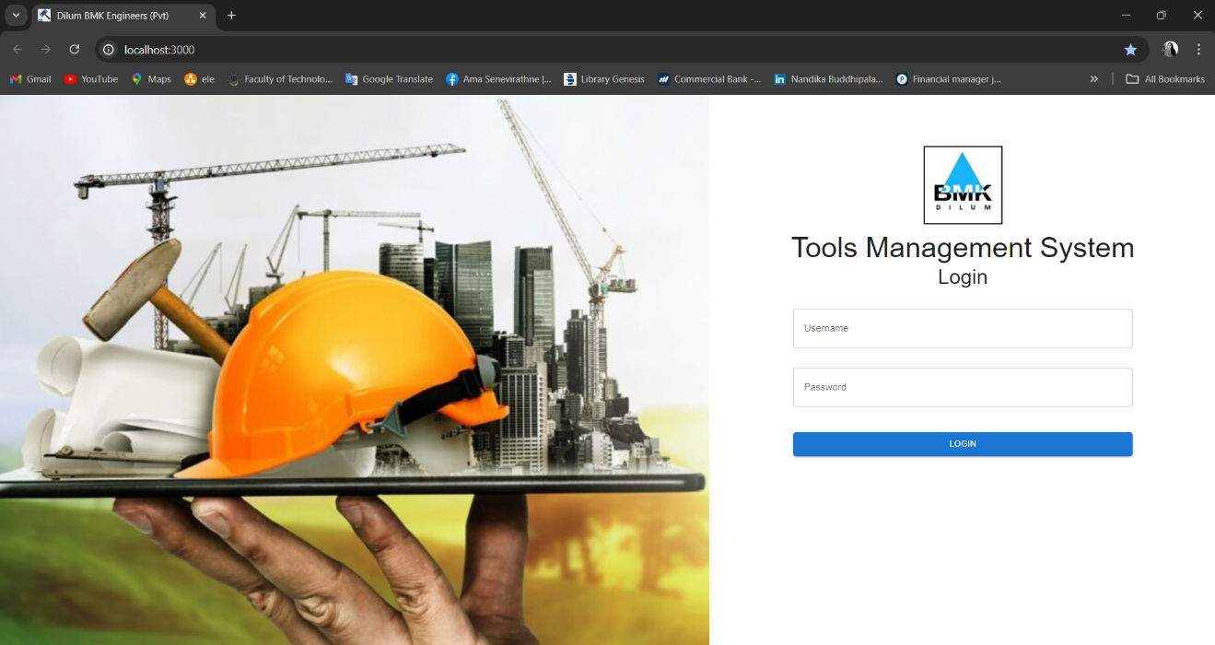

*Figure 2 – Login page of the web application.*

*Figure 3- Admin Dashboard*

*Figure 4 - Manage User Manage Page*

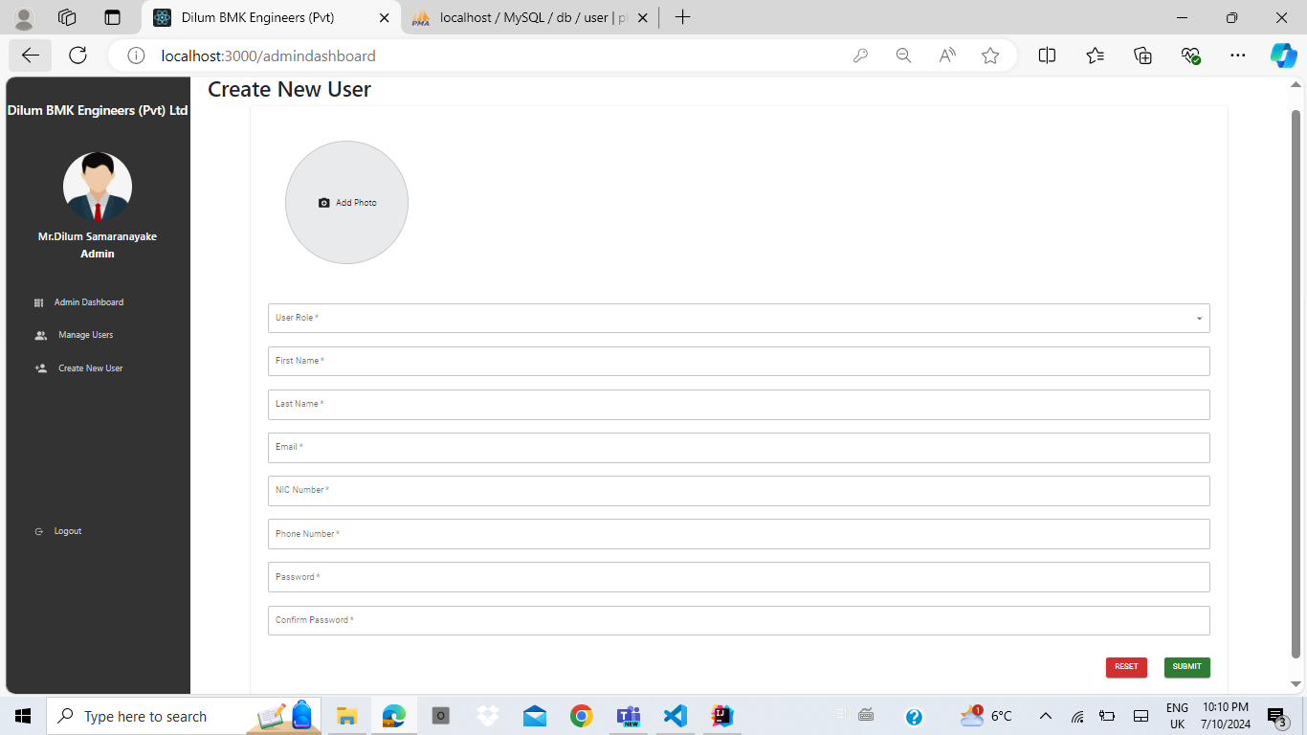

*Figure 5 - Create User Form*

*Figure 6 - Update User Form*

*Figure 7- Stock Supervisor Dashboard*

*Figure 8- Stock Supervisor View Tool Inventory*

*Figure 9 - Stock Supervisor Add New Tool Details Form*

*Figure 10- Stock Supervisor Update Tool Details Form*

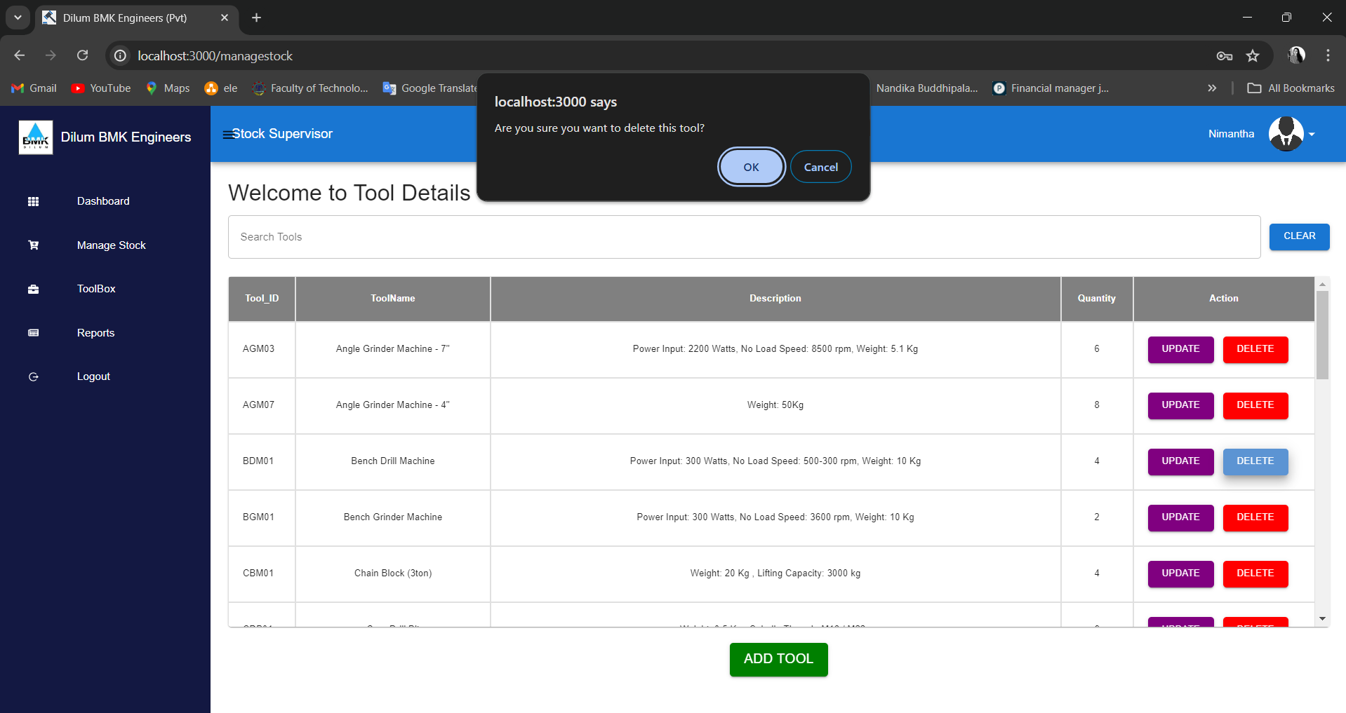

*Figure 11 - Stock Supervisor Tools Delete*

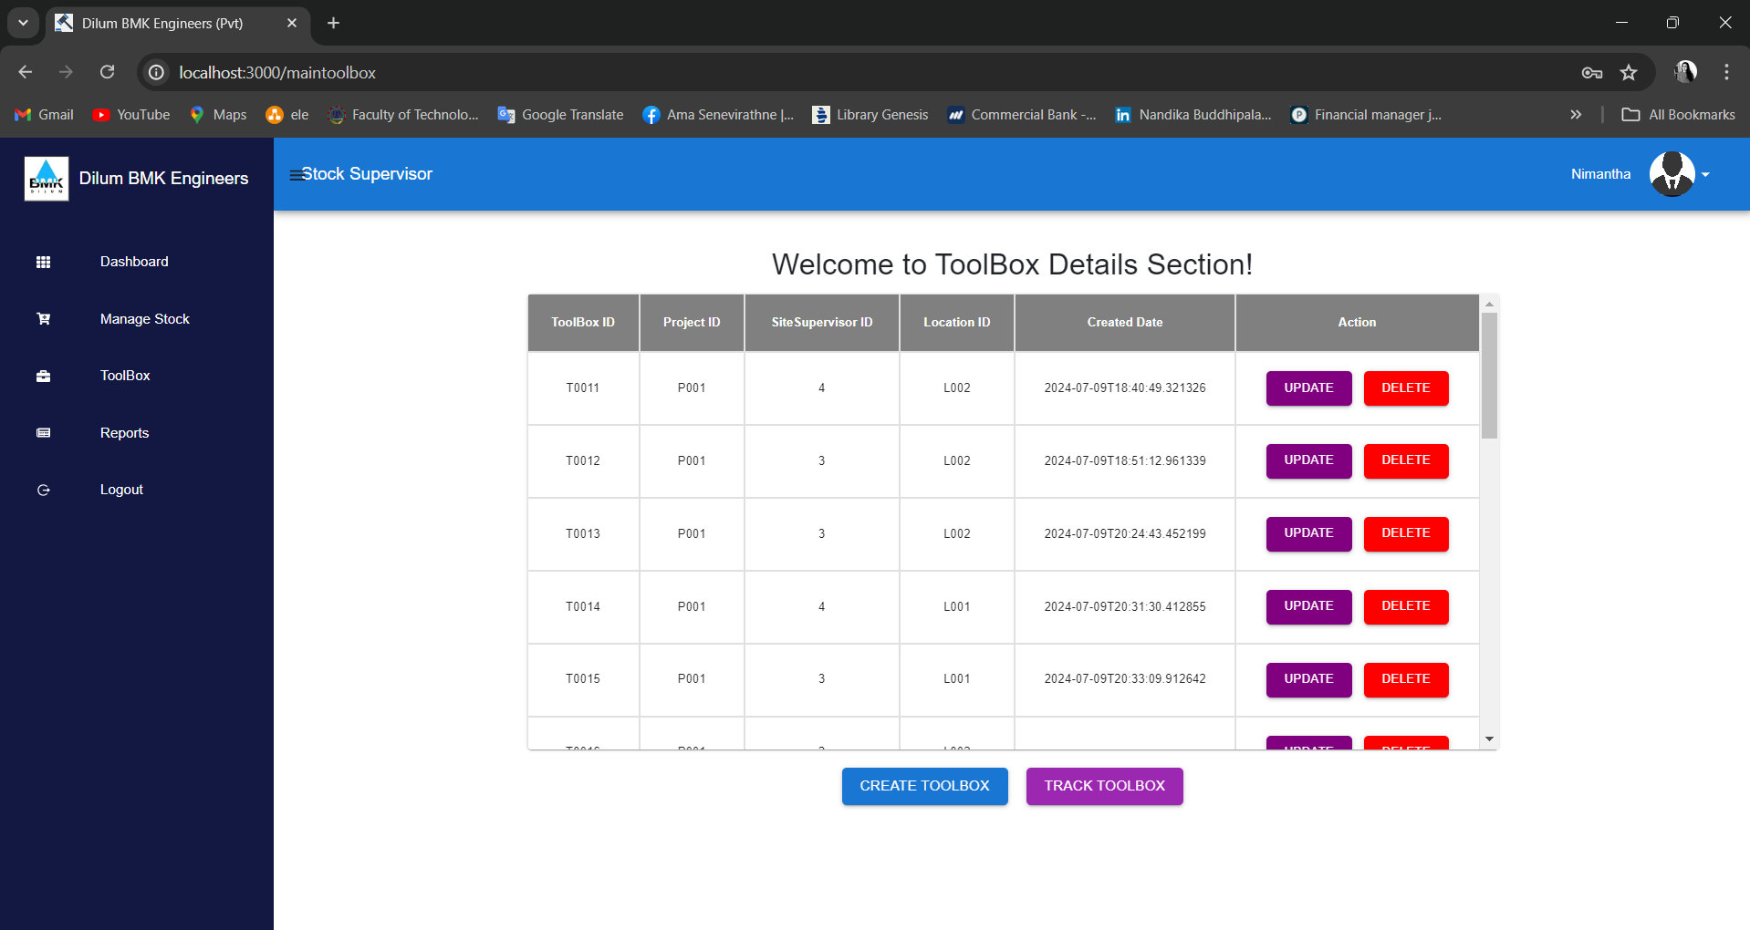

*Figure 12- Stock Supervisor Toolbox Dashboard*

*Figure 13 – Stock Supervisor Create New Toolbox Details Form*

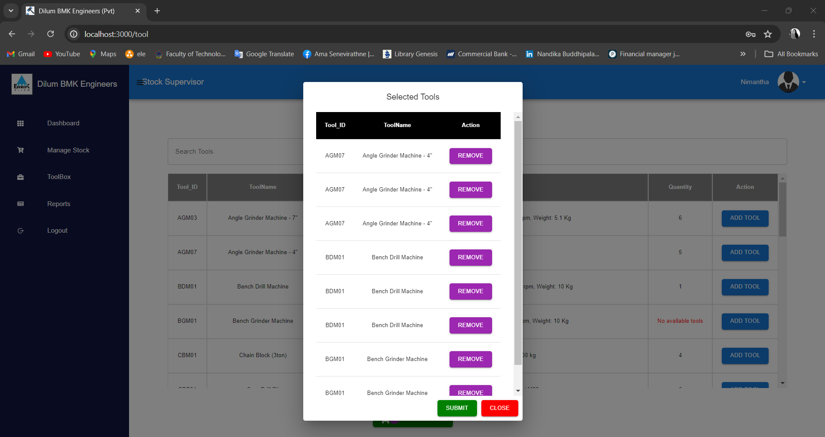

*Figure 14 - Stock Supervisor Selected Tools Section*

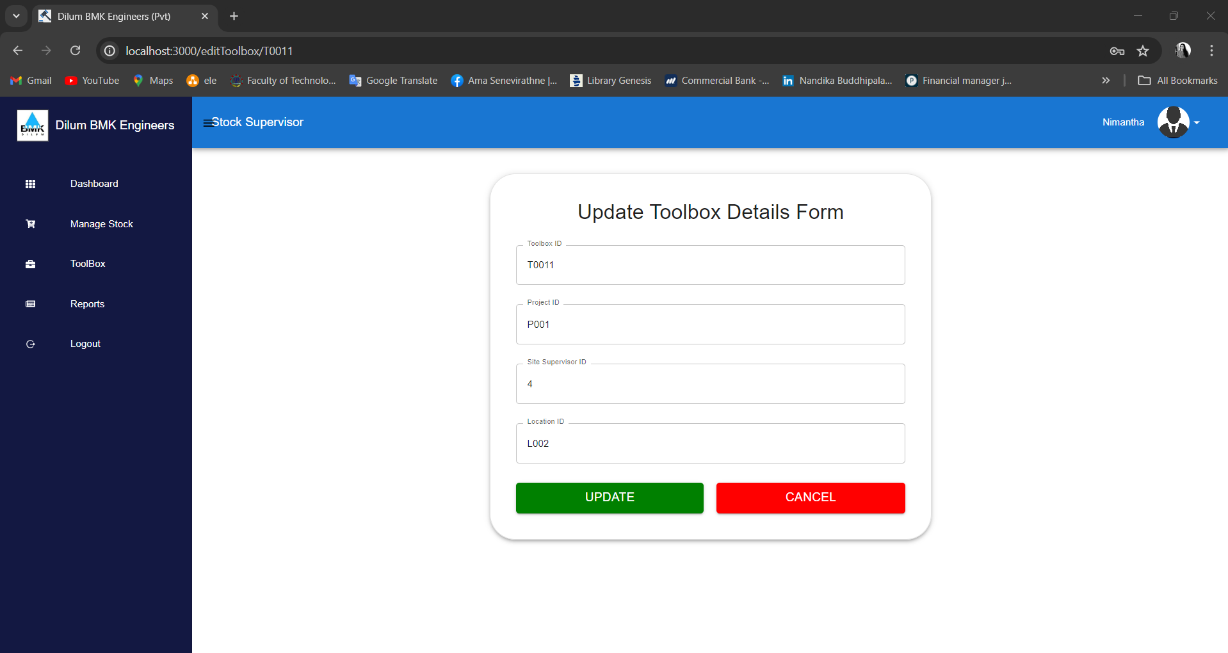

*Figure 15 - Stock Supervisor Update Toolbox Details Form*

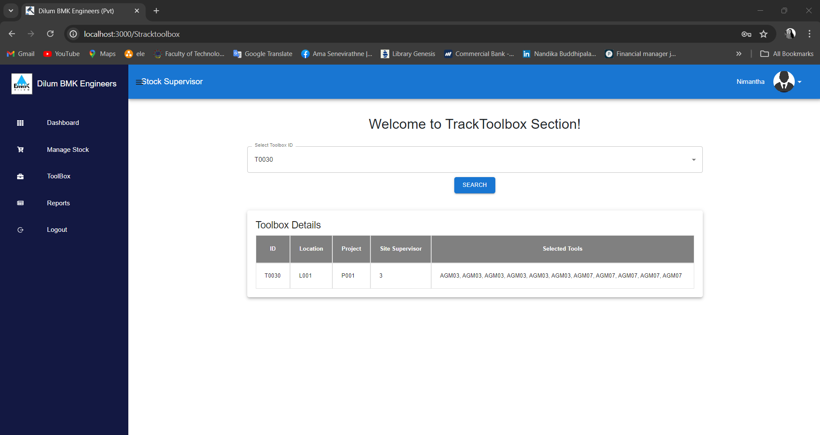

*Figure 16 - Stock Supervisor Track Toolbox Details view*

*Figure 17 -Stock Supervisor View Report Page.*

*Figure 18- Manager Dashboard*

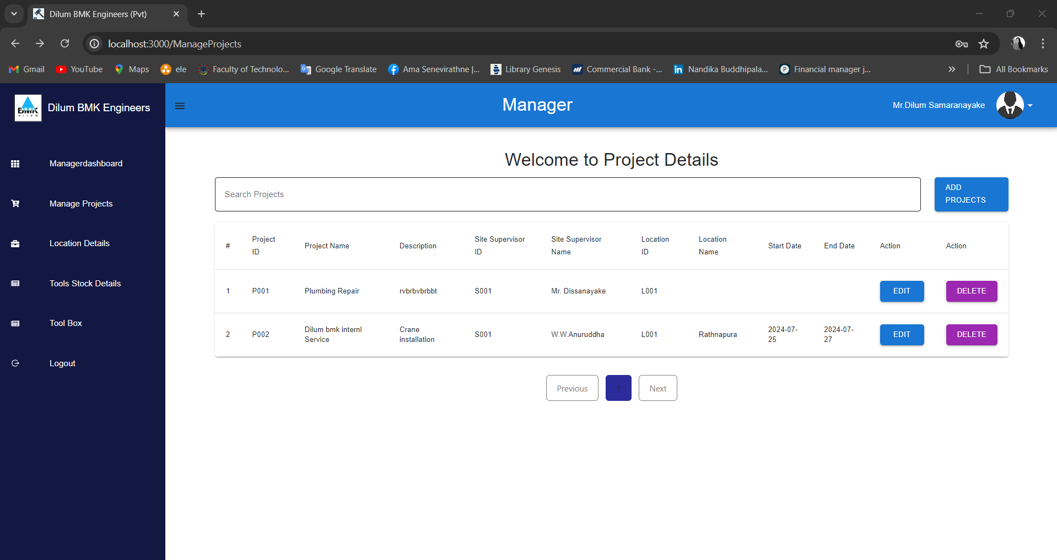

*Figure 19- Manager Manage Project details*

*Figure 19- Manager Add New Project details Form*

*Figure 20- Manager view Toolbox Details Page*

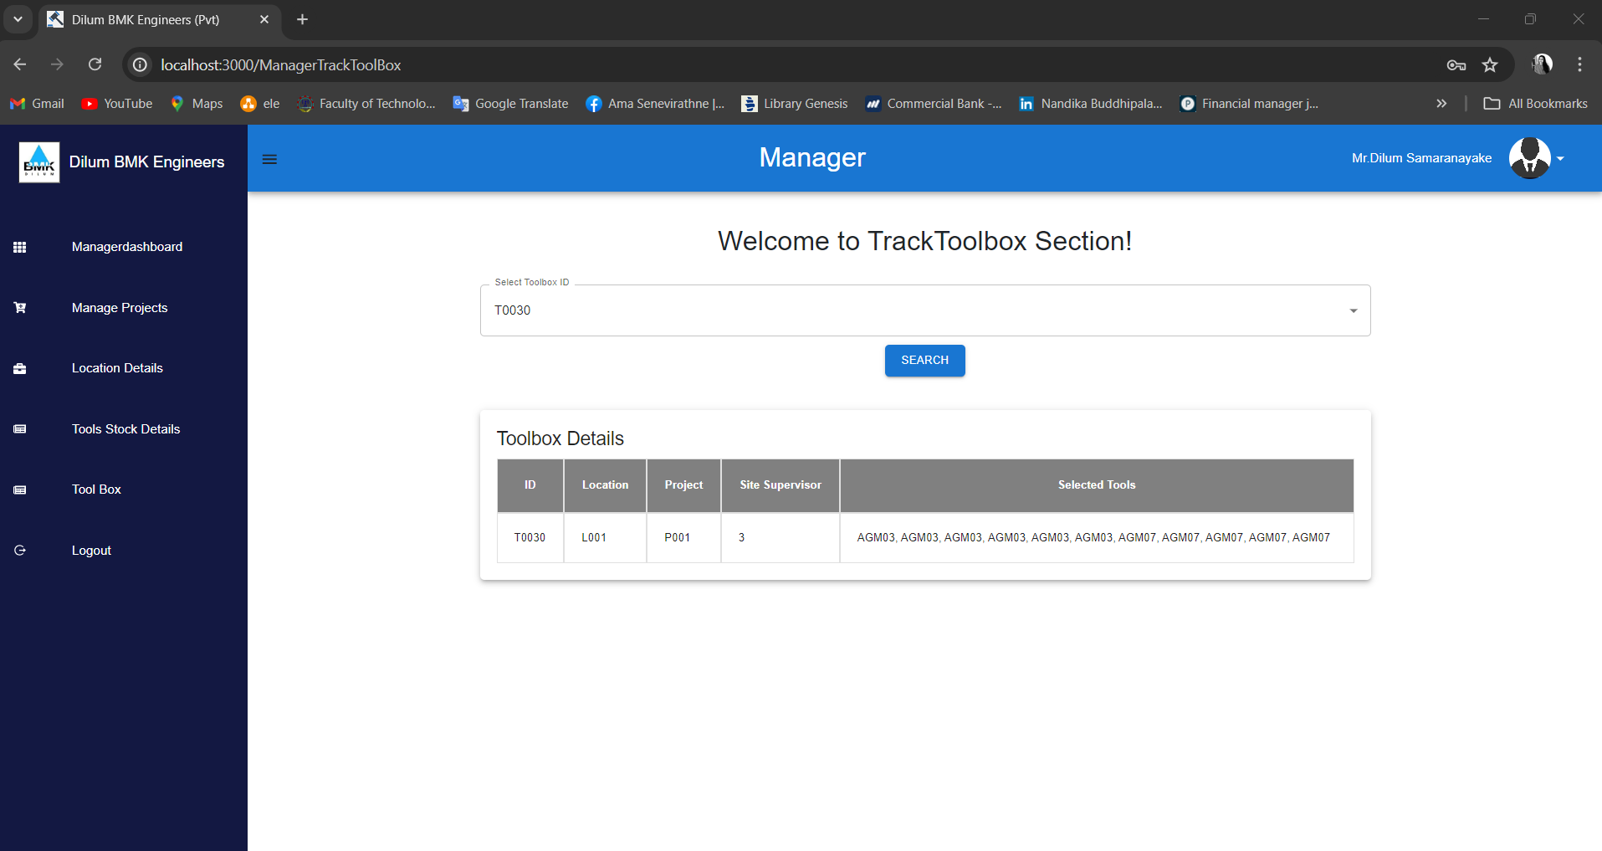

*Figure 21- Manager view Track Toolbox Details*

*Figure 22- Manager Add Location Details Form*

*Figure 23- Manager Edit Location Details Form*

*Figure 24- Manager view Tool Details page*

*Figure 25- Site Supervisor Dashboard*

*Figure 26- Site Supervisor View Tool status Reports page*

*Figure 27 - Site Supervisor View Required Tool Reports page*

*Figure 28 - Site Supervisor View Project Details page*

*Figure 28 - Site Supervisor Create Tool Status Report page*

*Figure 29 - Site Supervisor view Required Tool Report page*

*Figure 30 - Site Supervisor Add Tool Status Report Form page*

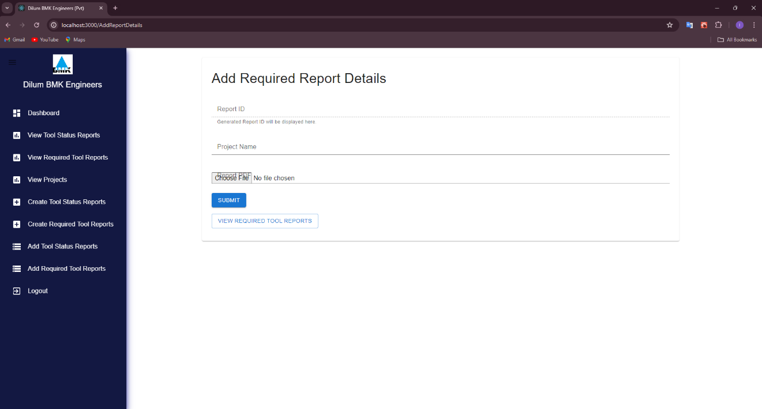

*Figure 31 - Site Supervisor Add Required Tool Report Form page*

#### **3.2 Hardware Interfaces**

Hardware interfaces are computers in additionally we need keyboards and mouses as helping for computes.

#### **3.3 Software Interfaces**

Operating System: the development utilizes the Windows operating system due to user friendly nature and provide an efficient computing experience.

Database: a database organized the collection of data that is stored and accessed electronically through a system. The company tool information and users’ information data are stored and managed by the tool management system using a database.

Visual Studio Code: it is a lightweight source code editor to develop the front end in our system.it supports multiple programming languages and provide cross-platform compatibility.

IntelliJ Idea: it is a powerful integrated development environment (IDE) primarily designed for java development with spring boot framework. We used to develop the back-end environment in our system.

#### **3.4 Communication Interfaces**

For the Tool Management web application system, will need various communication interfaces to ensure seamless interaction between the frontend and backend.

RESTful API: implement the RESTful API using Spring Boot to handle communication between the frontend and backend.

HTTP/HTTPS: that protocols for transmitting data between the frontend and backend. That are widely supported protocols for communication over the web.

Responsive Design: design the front end using responsive web design principles to ensure compatibility and optimal user experience across different devices and screen sized, including desktops, laptops, tablets, and smartphones.

# 4. System Features

### 4.1 Use Case Diagram

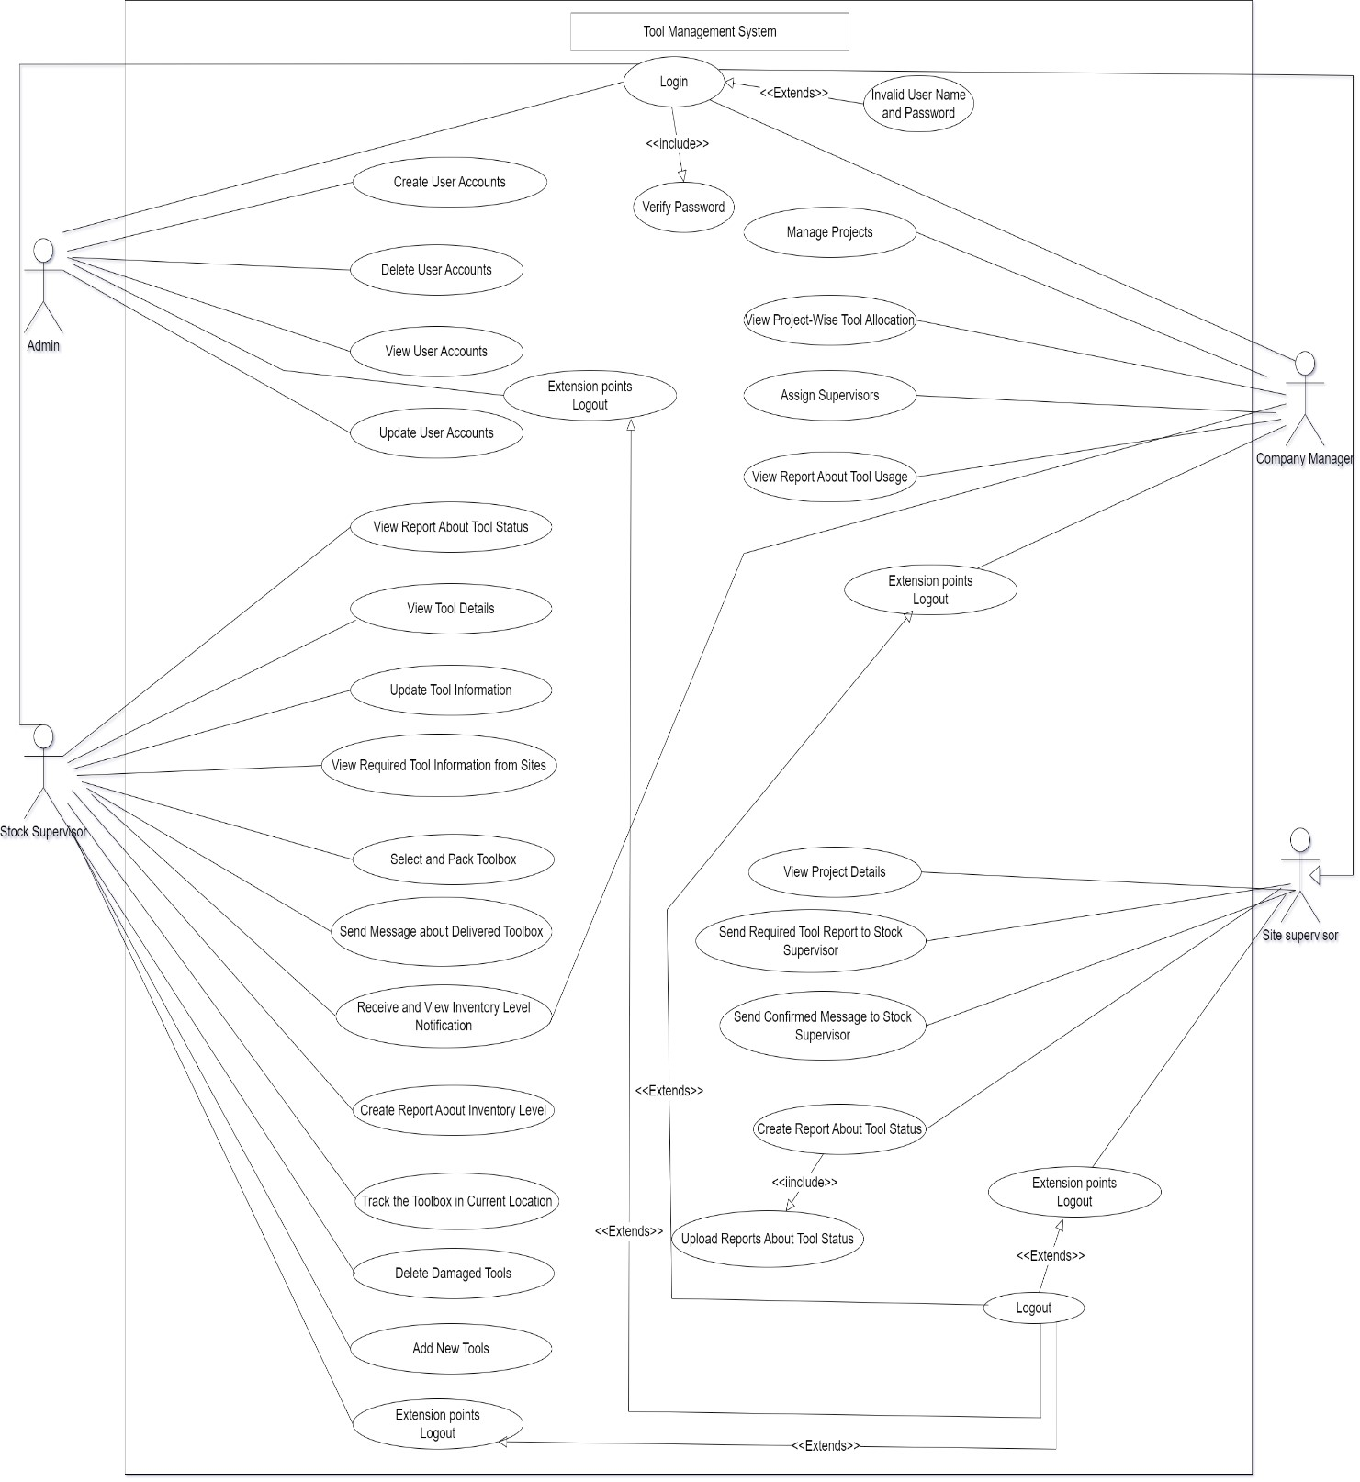

*Figure 18 - Use Case Diagram*

### 4.2 ER Diagram

*Figure 19 - ER Diagram*

### 4.3 Data Flow Diagram

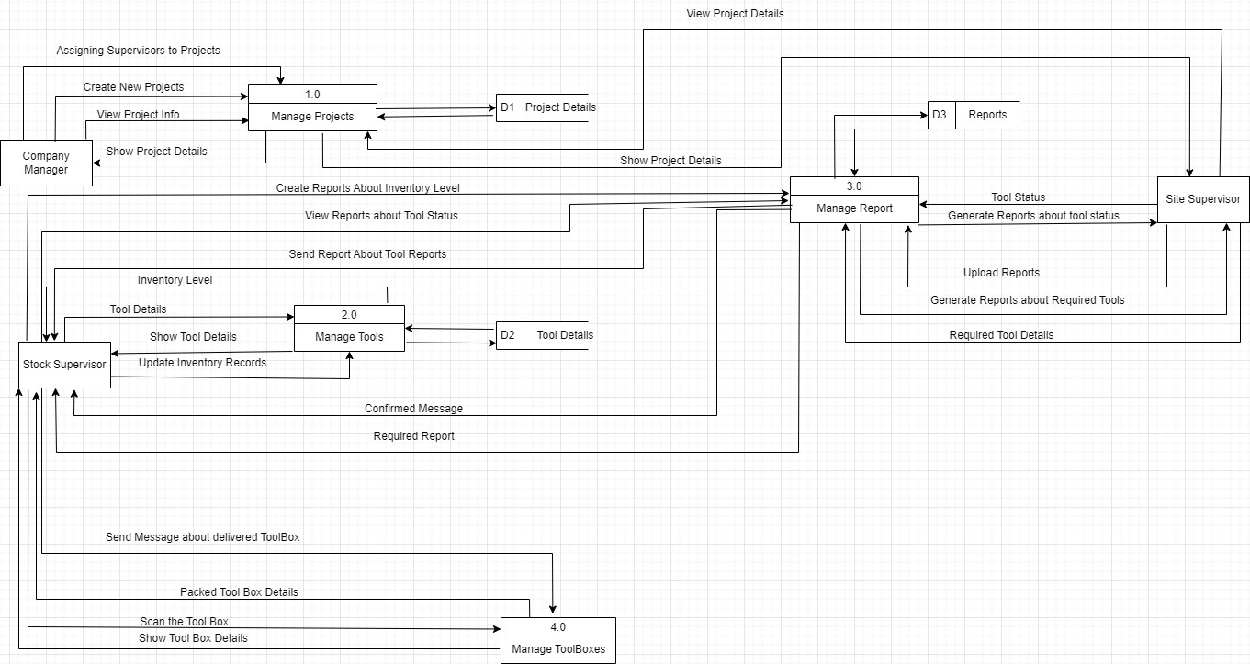

*Figure 20 – Data Flow Diagram*

### 

### 4.4 Test Case Description

|  |  |  |  |  |  |  |  |  |  |  |
| --- | --- | --- | --- | --- | --- | --- | --- | --- | --- | --- |
| Test case ID | | TC_01 | | Test Case description | | | | Test the login functionality in Tool Management System | | |
| Created by | | Ama | | Date Created | | March 30, 2024 | |  | | |
|  | | | | | | | | | | |
| Tester’s Name | | Ama | | Date Tested | | March 30, 2024 | | Test case | | Pass |
|  | | | | | | | | | | |
| S# | | Prerequisites | | | S# | | | Test Data | | |
| 1 | | Access to chrome browser | | | 1 | | | Username = [isuru@gmail.com](mailto:isuru@gmail.com) | | |
| 2 | | The user must be registered user in the system. | | | 2 | | | Password = isu0ru@123 | | |
|  | | | | | | | | | | |
| Test Scenario | | Verify on entering valid username and password, the user can login to the system and redirected to their dashboard. | | | | | | | | |
|  | | | | | | | | | | |
| Step # | Step Details | | Expected Results | | | | Actual Results | | Pass/Fail/Not executed/ Suspended | |
| 1 | Navigate to Tool Management System | | Site should open | | | | As Expected, | | Pass | |
| 2 | Enter Username & Password | | Credential can be | | | | As Expected, | | Pass | |
| 3 | Click Login button | | Successfully login and Redirect user dashboard | | | | As Expected, | | Pass | |

|  |  |  |  |  |  |  |  |  |  |  |
| --- | --- | --- | --- | --- | --- | --- | --- | --- | --- | --- |
| Test case ID | | TC_02 | | Test Case description | | | | Test the login functionality in Tool Management System | | |
| Created by | | Ama | | Date Created | | March 30, 2024 | |  | | |
|  | | | | | | | | | | |
| Tester’s Name | | Ama | | Date Tested | | March 30, 2024 | | Test case | | Pass |
|  | | | | | | | | | | |
| S# | | Prerequisites | | | S# | | | Test Data | | |
| 1 | | Access to chrome browser | | | 1 | | | Invalid Username = [isurugmail.com](mailto:isuru@gmail.com) | | |
| 2 | | The user must be registered user in the system. | | | 2 | | | Password = isuru@123 | | |
|  | | | | | | | | | | |
| Test Scenario | | Verify on entering invalid username and valid password, the user cannot login to the system | | | | | | | | |
|  | | | | | | | | | | |
| Step # | Step Details | | Expected Results | | | | Actual Results | | Pass/Fail/Not executed/ Suspended | |
| 1 | Navigate to  Tool Management System | | Site should open | | | | As Expected | | Pass | |
| 2 | Enter invalid Username & valid Password | | Credential can be entered | | | | As Expected | | Pass | |
| 3 | Click Login button | | Display “required valid email with @ ” | | | |  | | Pass | |

|  |  |  |  |  |  |  |  |  |  |  |
| --- | --- | --- | --- | --- | --- | --- | --- | --- | --- | --- |
| Test case ID | | TC_03 | | Test Case description | | | | Test the login functionality in Tool Management System | | |
| Created by | | Ama | | Date Created | | March 30, 2024 | |  | | |
|  | | | | | | | | | | |
| Tester’s Name | | Ama | | Date Tested | | March 30, 2024 | | Test case | | Pass |
|  | | | | | | | | | | |
| S# | | Prerequisites | | | S# | | | Test Data | | |
| 1 | | Access to chrome browser | | | 1 | | | Username = [isuru@gmail.com](mailto:isuru@gmail.com) | | |
| 2 | | The user must be registered user in the system. | | | 2 | | | Password = is@12 | | |
|  | | | | | | | | | | |
| Test Scenario | | Verify on entering valid username and invalid password, the user cannot login to the system | | | | | | | | |
|  | | | | | | | | | | |
| Step # | Step Details | | Expected Results | | | | Actual Results | | Pass/Fail/Not executed/ Suspended | |
| 1 | Navigate to  Tool Management System | | Site should open | | | | As Expected, | | Pass | |
| 2 | Enter valid Username & invalid Password | | Credential can be entered | | | | As Expected, | | Pass | |
| 3 | Click Login button | | Display error message “Password must be more than 8 characteristics and should be valid” | | | | As Expected, | | Pass | |

|  |  |  |  |  |  |  |  |  |  |  |
| --- | --- | --- | --- | --- | --- | --- | --- | --- | --- | --- |
| Test case ID | | TC_04 | | Test Case description | | | | Test the insert of Tools into the inventory in the Tool Management System | | |
| Created by | | Ama | | Date Created | | March 30, 2024 | |  | | |
|  | | | | | | | | | | |
| Tester’s Name | | Ama | | Date Tested | | March 30, 2024 | | Test case | | Pass |
|  | | | | | | | | | | |
| S# | | Prerequisites | | | S# | | | Test Data | | |
| 1 | | Access to chrome browser | | | 1 | | | Tool_ID = T001 | | |
| 2 | | Login to the Tools Management System | | | 2 | | | Tool name = Angle Grinder Machine | | |
| 3 | | Access to the Stock Supervisor Dashboard | | | 3 | | | Description: weight 50 | | |
| 4 | | Access to Manage Stock interface | | | 4 | | | Quantity = 10 | | |
|  | | | | |  | | |  | | |
|  | | | | | | | | | | |
| Test Scenario | | Verify on entering valid tool details, Stock Supervisor can add new Tool details | | | | | | | | |
|  | | | | | | | | | | |
| Step # | Step Details | | Expected Results | | | | Actual Results | | Pass/Fail/Not executed/ Suspended | |
| 1 | Navigate to  Tool Management System | | Site should open | | | | As Expected | | Pass | |
| 2 | Enter Tool_ID , Tool name, Description and Quantity | | Credential can be | | | | As Expected | | Pass | |
| 3 | Click Add button | | Stock Supervisor can add new tool Details | | | | As Expected | | Pass | |

|  |  |  |  |  |  |  |  |  |  |  |
| --- | --- | --- | --- | --- | --- | --- | --- | --- | --- | --- |
| Test case ID | | TC_05 | | Test Case description | | | | Test the insert Tools into the inventory in the Tool Management System | | |
| Created by | | Ama | | Date Created | | March 30, 2024 | |  | | |
|  | | | | | | | | | | |
| Tester’s Name | | Ama | | Date Tested | | March 30, 2024 | | Test case | | Pass |
|  | | | | | | | | | | |
| S# | | Prerequisites | | | S# | | | Test Data | | |
| 1 | | Access to chrome browser | | | 1 | | | ToolID = 1 | | |
| 2 | | Login to the Tools Management System | | | 2 | | | Tool name = Angle Grinder Machine | | |
| 3 | | Access to the Stock Supervisor Dashboard | | | 3 | | | description | | |
| 4 | | Access to Manage Stock interface | | | 4 | | | Quantity = 10 | | |
|  | | | | |
|  | | | | | | | | | | |
| Test Scenario | | Verify on entering invalid toolID details, Stock Supervisor cannot add new Tool details | | | | | | | | |
|  | | | | | | | | | | |
| Step # | Step Details | | Expected Results | | | | Actual Results | | Pass/Fail/Not executed/ Suspended | |
| 1 | Navigate to  Tool Management System | | Site should open | | | | As Expected, | | Pass | |
| 2 | Insert invalid ToolID , Tool name, Description, and Quantity | | Display an Alert of error “Enter String type ToolID “ | | | | As Expected, | | Pass | |
| 3 | Click Add button | | Display an error message “New Tool details are not added successfully” | | | | As Expected, | | Pass | |

|  |  |  |  |  |  |  |  |  |  |  |
| --- | --- | --- | --- | --- | --- | --- | --- | --- | --- | --- |
| Test case ID | | TC_07 | | Test Case description | | | | Test the Update Tools details in the inventory in the Tool Management System | | |
| Created by | | Ama | | Date Created | | March 30, 2024 | |  | | |
|  | | | | | | | | | | |
| Tester’s Name | | Ama | | Date Tested | | March 30, 2024 | | Test case | | Pass |
|  | | | | | | | | | | |
| S# | | Prerequisites | | | S# | | | Test Data | | |
| 1 | | Access to chrome browser | | |  | | |  | | |
| 2 | | Login to the Tools Management System | | | 1 | | | Tool name = Angle Grinder Machine “7” | | |
| 3 | | Access to the Stock Supervisor Dashboard | | | 2 | | | description | | |
| 4 | | Access the Manage Stock Interface | | | 3 | | | Quantity = 10 | | |
| 5 | | When click update button open the tool details form | | |  | | |  | | |
|  | | | | |  | | |  | | |
|  | | | | | | | | | | |
| Test Scenario | | Update valid tool details, Stock Supervisor can update existing Tool details | | | | | | | | |
|  | | | | | | | | | | |
| Step # | Step Details | | Expected Results | | | | Actual Results | | Pass/Fail/Not executed/ Suspended | |
| 1 | Navigate to  Tool Management System | | Site should open | | | | As Expected, | | Pass | |
| 2 | Update Tool name, Description and Quantity | | Credential can be | | | | As Expected, | | Pass | |
| 3 | Click Update button | | Stock Supervisor can Update existing Tool Details. | | | | As Expected, | | Pass | |

|  |  |  |  |  |  |  |  |  |  |  |
| --- | --- | --- | --- | --- | --- | --- | --- | --- | --- | --- |
| Test case ID | | TC_08 | | Test Case description | | | | Test the Update Tools details in the inventory in the Tool Management System | | |
| Created by | | Ama | | Date Created | | March 30, 2024 | |  | | |
|  | | | | | | | | | | |
| Tester’s Name | | Ama | | Date Tested | | March 30, 2024 | | Test case | | Pass |
|  | | | | | | | | | | |
| S# | | Prerequisites | | | S# | | | Test Data | | |
| 1 | | Access to chrome browser | | | 1 | | | ToolID = T003 | | |
| 2 | | Login to the Tools Management System | | | 2 | | | Tool name = Angle Grinder Machine “7” | | |
| 3 | | Access to the Stock Supervisor Dashboard | | | 3 | | | description | | |
| 4 | | Access the Manage Stock Interface | | | 4 | | | Quantity = 10 | | |
| 5 | | When click update button open the tool details form | | |  | | |  | | |
|  | | | | |  | | |  | | |
|  | | | | | | | | | | |
| Test Scenario | | Update ToolID , Stock Supervisor cannot update existing Tool details | | | | | | | | |
|  | | | | | | | | | | |
| Step # | Step Details | | Expected Results | | | | Actual Results | | Pass/Fail/Not executed/ Suspended | |
| 1 | Navigate to  Tool Management System | | Site should open | | | | As Expected, | | Pass | |
| 2 | Update Tool name, Description and Quantity, with ToolID | | can’t update “ToolID” | | | | As Expected, | | Pass | |
| 3 | | | | | | | | | | |

|  |  |  |  |  |  |  |  |  |  |  |
| --- | --- | --- | --- | --- | --- | --- | --- | --- | --- | --- |
| Test case ID | | TC_09 | | Test Case description | | | | Test the Update Tools details in the inventory in the Tool Management System | | |
| Created by | | Ama | | Date Created | | March 30, 2024 | |  | | |
|  | | | | | | | | | | |
| Tester’s Name | | Ama | | Date Tested | | March 30, 2024 | | Test case | | Pass |
|  | | | | | | | | | | |
| S# | | Prerequisites | | | S# | | | Test Data | | |
| 1 | | Access to chrome browser | | |  | | |  | | |
| 2 | | Login to the Tools Management System | | | 1 | | | Tool name = Angle Grinder Machine “7” | | |
| 3 | | Access to the Stock Supervisor Dashboard | | | 2 | | | description | | |
| 4 | | Access the Manage Stock Interface | | | 3 | | | Quantity <0 | | |
| 5 | | When click update button open the tool details form | | |  | | |  | | |
|  | | | | |  | | |  | | |
|  | | | | | | | | | | |
| Test Scenario | | Update invalid Quantity value, Stock Supervisor cannot update existing Tool details | | | | | | | | |
|  | | | | | | | | | | |
| Step # | Step Details | | Expected Results | | | | Actual Results | | Pass/Fail/Not executed/ Suspended | |
| 1 | Navigate to  Tool Management System | | Site should open | | | | As Expected | | Pass | |
| 2 | Update Tool name, Description, and invalid Quantity type (minus value) | | Display an Alert of error “cannot select the minus value for quantity” | | | | As Expected | | Pass | |
| 3 | Click Update button | | Display an error message “Tool details are not updated successfully” | | | | As Expected | | Pass | |

|  |  |  |  |  |  |  |  |  |  |  |
| --- | --- | --- | --- | --- | --- | --- | --- | --- | --- | --- |
| Test case ID | | TC_10 | | Test Case description | | | | Test deleteTools details in the inventory of the Tool Management System | | |
| Created by | | Ama | | Date Created | | March 30, 2024 | |  | | |
|  | | | | | | | | | | |
| Tester’s Name | | Ama | | Date Tested | | March 30, 2024 | | Test case | | Pass |
|  | | | | | | | | | | |
| S# | | Prerequisites | | | S# | | | Test Data | | |
| 1 | | Access to chrome browser | | |  | | |  | | |
| 2 | | Login to the Tools Management System | | | 1 | | | ToolID = T001 | | |
| 3 | | Access to the Stock Supervisor Dashboard | | |  | | |  | | |
| 4 | | Access the Manage Stock Interface | | |  | | |  | | |
| 5 | | Click on the View option | | |  | | |  | | |
|  | | | | |  | | |  | | |
|  | | | | | | | | | | |
| Test Scenario | | View existing tool details, Stock Supervisor can access and view Tool details | | | | | | | | |
|  | | | | | | | | | | |
| Step # | Step Details | | Expected Results | | | | Actual Results | | Pass/Fail/Not executed/ Suspended | |
| 1 | Navigate to  Tool Manage | | Site should open | | | | As Expected | | Pass | |
| 2 | Search tool from ID or name and view tool details option. | | Tool Details should be displayed | | | | As Expected | | Pass | |
| 3 | Click Delete button and Display Confirm Message “If click ok” | | Display message “ ToolDetails Delete Successfully“Delete | | | | As Expected | | Pass | |

|  |  |  |  |  |  |  |  |  |  |  |
| --- | --- | --- | --- | --- | --- | --- | --- | --- | --- | --- |
| Test case ID | | TC_11 | | Test Case description | | | | Test the Create New Toolbox details in the inventory in the Tool Management System | | |
| Created by | | Ama | | Date Created | | April 04 2024 | |  | | |
|  | | | | | | | | | | |
| Tester’s Name | | Ama | | Date Tested | | April 08, 2024 | | Test case | | Pass |
|  | | | | | | | | | | |
| S# | | Prerequisites | | | S# | | | Test Data | | |
| 1 | | Access to chrome browser | | | 1 | | | ToolboxID = T0031 | | |
| 2 | | Login to the Tools Management System | | | 2 | | | Project = Plumbing Repair | | |
| 3 | | Access to the Stock Supervisor Dashboard | | | 3 | | | SiteSupervisor = Kusal Senarathne | | |
| 4 | | Access the ToolBox Interface | | | 4 | | | Location = Rathnapura | | |
| 5 | | When click Create Toolbox Button navigate to Create New Toolbox Details Form | | | 5 | | | Selected Tools = “Angle Grinder Machine-7, Bench Drill Machine” | | |
|  | | | | | | | | | | |
|  | | | | | | | | | | |
| Test Scenario | | Create New Toolbox, Stock Supervisor can create New Toolbox details | | | | | | | | |
|  | | | | | | | | | | |
| Step # | Step Details | | Expected Results | | | | Actual Results | | Pass/Fail/Not executed/ Suspended | |
| 1 | Navigate to  Tool Management System | | Site should open | | | | As Expected, | | Pass | |
| 2 | Enter Toolbox_ID , Project Sitesupervisor, Location, select tools | | Credential can be | | | | As Expected, | | Pass | |
| 3 | Click “Submit “button | | Display Message “Successfully Created New Toolbox “ | | | | As Expected, | | Pass | |
| 3 | | | | | | | | | | |

|  |  |  |  |  |  |  |  |  |  |  |
| --- | --- | --- | --- | --- | --- | --- | --- | --- | --- | --- |
| Test case ID | | TC_12 | | Test Case description | | | | Test the Create New Toolbox in the Tool Management System | | |
| Created by | | Ama | | Date Created | | April 04, 2024 | |  | | |
|  | | | | | | | | | | |
| Tester’s Name | | Ama | | Date Tested | | April 08, 2024 | | Test case | | Pass |
|  | | | | | | | | | | |
| S# | | Prerequisites | | | S# | | | Test Data | | |
| 1 | | Access to chrome browser | | | 1 | | | Toolbox ID = T0031 | | |
| 2 | | Login to the Tools Management System | | | 2 | | | Project | | |
| 3 | | Access to the Stock Supervisor Dashboard | | | 3 | | | Site Supervisor = | | |
| 4 | | Access to Manage Stock interface | | | 4 | | | Location = Rathnapura | | |
|  | |  | | | 5 | | | Selected Tools = “Angle Grinder Machine-7, Bench Drill Machine” | | |
|  | | | | |
|  | | | | | | | | | | |
| Test Scenario | | Verify on entering invalid toolbox details as not fill the data values, Stock Supervisor cannot add new Tool details | | | | | | | | |
|  | | | | | | | | | | |
| Step # | Step Details | | Expected Results | | | | Actual Results | | Pass/Fail/Not executed/ Suspended | |
| 1 | Navigate to  Tool Management System | | Site should open | | | | As Expected, | | Pass | |
| 2 | Not enter the values to field in the toolbox create form | | Display an Alert of error” Fill the all data values in the field “ | | | | As Expected, | | Pass | |
| 3 | Click Add button | | Display an error message “New Toolbox details are not added successfully” | | | | As Expected, | | Pass | |

|  |  |  |  |  |  |  |  |  |  |  |
| --- | --- | --- | --- | --- | --- | --- | --- | --- | --- | --- |
| Test case ID | | TC_12 | | Test Case description | | | | Test the successful tool assignment | | |
| Created by | | Ganga | | Date  Created | | March 30, 2024 | |  | | |
|  | | | | | | | | | | |
| Tester’s Name | | Ganga | | Date Tested | | March 30, 2024, | | Test case | | Pass |
|  | | | | | | | | | | |
| S# | | Prerequisites | | | S# | | | Test Data | | |
| 1 | | Access to chrome browser | | | 1 | | | Project_Id= 001 | | |
| 2 | | Login to the Tools Management  System | | | 2 | | | Project_name =  Water Treatment  Plant Expansion | | |
| 3 | | Access to the Site Supervisor Dashboard | | | 3 | | |  | | |
|  | | | | |  | | | Quantity = 10 | | |
|  | | | | | | | | | | |
| Test Scenario | | Test the successful tool assignment | | | | | | | | |
|  | | | | | | | | | | |
| Step # | Step Details | | Expected Results | | | | Actual Results | | Pass/Fail/Not executed/ Suspended | |
| 1 | select specific project | | System displays a list of available projects and choose desired project | | | | As expected | | Pass | |
| 2 | Navigates to the tool inventory | | System  redirects site supervisor to the tool inventory section | | | | System successfully redirects the site supervisor to the tool inventory section | | Pass | |
| 3 | Selects required tools. | | Display s list of available tools and can be choose the require ones. | | | | As  Expected | | Pass | |
| 4 | Assigns tools to the project | | The system confirms successful assignment of tool to the chosen project. | | | | Successfully assigns the selected tools to the chosen project and displays a success message. | |  | |

|  |  |  |  |  |
| --- | --- | --- | --- | --- |
|  |  | supervisor to the project details page for the selected project on the project details page |  |  |
| 3 | Verifies the list of assigned the list of assigned tools. | System displays the list of tools assigned to the project details page. | As  Expected | Pass |
| 4 | Cross references the assigned | Compares | As expected. | Pass |
|  | tools. | the list of assigned tools displayed on the project details page with the inventory records. |  |  |

|  |  |  |  |  |  |  |
| --- | --- | --- | --- | --- | --- | --- |
| Test case ID | TC14 | Test Case description | | | Test the  Unsuccessful tool assignment | |
| Created by | Ganga | Date  Created | | March 30, 2024 |  | |
|  |  | | | |  | |
| Tester’s Name | Ganga | Date Tested | | March 30, 2024 | Test case | Pass |
|  |  | | | |  | |
| S# | Prerequisites | | S# | | Test Data | |
| 1 | Access to chrome browser | | 1 | | Project_Id= 001 | |
| 2 | Login to the Tools Management  System | | 2 | | Project_name =  Water Treatment  Plant Expansion | |
| 3 | Access to the Site Supervisor Dashboard | | 3 | |  | |
|  |  | |  | | Quantity = 10 | |
|  |  | | | |  | |
| Test Scenario | Verify Unsuccessful tool assignment | | | |  | |
|  |  | | | |  | |
|  |  | | | |  | |

|  |  |  |  |  |
| --- | --- | --- | --- | --- |
|  | | | | |
| Step # | Step Details | Expected Results | Actual Results | Pass/Fail/Not executed/ Suspended |
| 1 | select specific project | System | As | Pass |
|  |  | displays a list of available projects and choose desired project | expected |  |
| 2 | Attempts to assign tools | Check if the | Site | Pass |
|  |  | selected tool | supervisor |  |
|  |  | is available | attempts to |  |
|  |  | in the | assign the |  |
|  |  | inventory | tools , but it |  |
|  |  | and not | is already |  |
|  |  | assigned to | assigned to |  |
|  |  | another | another |  |
|  |  | project | project or  unavailable in inventory. |  |
| 3 | Verifies the assignment | Displays an | As | Pass |
|  | status | error message indication that the tool assignment was unsuccessful | Expected |  |
| 4 | Assigns tools to the project | The project details and records remain unchanged, showing no  assignment of tools to the project. | Project details and inventory records remain unchanged, indicating that the tool assignment did not occur | Pass |

|  |  |  |  |  |  |  |  |  |  |  |
| --- | --- | --- | --- | --- | --- | --- | --- | --- | --- | --- |
| Test case ID | | TC15 | | Test Case description | | | | Test Status report creating | | |
| Created by | | Ganga | | Date  Created | | March 30, 2024 | |  | | |
|  | | | | | | | | | | |
| Tester’s Name | | Ganga | | Date Tested | | March 30, 2024 | | Test case | | Pass |
|  | | | | | | | | | | |
| S# | | Prerequisites | | | S# | | | Test Data | | |
| 1 | | Access to chrome browser | | | 1 | | | Report_Id= Rep001 | | |
| 2 | | Login to the Tools Management  System | | | 2 | | | Report_Type = Tool status report | | |
| 3 | | Access to the Site Supervisor Dashboard | | | 3 | | |  | | |
|  | | | | |  | | | Quantity = 5 | | |
|  | | | | | | | | | | |
| Test Scenario | | Test Status report creating | | | | | | | | |
|  | | | | | | | | | | |
| Step # | Step Details | | Expected Results | | | | Actual Results | | Pass/Fail/Not executed/ Suspended | |
| 1 | Navigates to the reporting section | | System provides an option for site supervisor to generate a report about tool status. | | | | As  Expected | | Pass | |
| 2 | Selects the option to create a report | | System presents a form where the site supervisor can input parameters for the report generation. | | | | As Expected | | Pass | |
| 3 | Fill the required information | | Inputs necessary details such as project name, tools Id, data range etc for the report. | | | | As  Expected | | Pass | |

|  |  |  |  |  |  |  |  |  |  |  |
| --- | --- | --- | --- | --- | --- | --- | --- | --- | --- | --- |
| Test case ID | | TC16 | | Test Case description | | | | Test generated report contains accurate information | | |
| Created by | | Ganga | | Date  Created | | March 30, 2024 | |  | | |
|  | | | | | | | | | | |
| Tester’s Name | | Ganga | | Date Tested | | March 30, 2024 | | Test case | | Pass |
|  | | | | | | | | | | |
| S# | | Prerequisites | | | S# | | | Test Data | | |
| 1 | | Access to chrome browser | | | 1 | | | Report_Id= 001 | | |
| 2 | | Login to the Tools Management  System | | | 2 | | | Report_type=Tool status report | | |
| 3 | | Access to the Site Supervisor Dashboard | | | 3 | | |  | | |
|  | | | | |  | | | Quantity = 5 | | |
|  | | | | | | | | | | |
| Test Scenario | | Test generated report contains accurate information | | | | | | | | |
|  | | | | | | | | | | |
| Step # | Step Details | | Expected Results | | | | Actual Results | | Pass/Fail/Not executed/ Suspended | |
| 1 | Receives the generated report. | | System delivers the generated report to the site supervisor in readable and accessible format | | | | As  Expected | | Pass | |
| 2 | Reviews the report contents. | | Generated report contains accurate | | | | As  Expected | | Pass | |

|  |  |  |  |  |  |  |  |  |  |  |
| --- | --- | --- | --- | --- | --- | --- | --- | --- | --- | --- |
| Test case ID | | TC17 | | Test Case description | | | | Test the  Unsuccessful tool status report generation | | |
| Created by | | Ganga | | Date  Created | | March 30, 2024 | |  | | |
|  | | | | | | | | | | |
| Tester’s Name | | Ganga | | Date Tested | | March 30, 2024 | | Test case | | Pass |
|  | | | | | | | | | | |
| S# | | Prerequisites | | | S# | | | Test Data | | |
| 1 | | Access to chrome browser | | | 1 | | | Report_Id= R001 | | |
| 2 | | Login to the Tools Management  System | | | 2 | | | Report_Type = Tool status report | | |
| 3 | | Access to the Site Supervisor Dashboard | | | 3 | | |  | | |
|  | | | | |  | | | Quantity = 5 | | |
|  | | | | | | | | | | |
| Test Scenario | | Verify Test the Unsuccessful tool status report generation | | | | | | | | |
|  | | | | | | | | | | |
| Step # | Step Details | | Expected Results | | | | Actual Results | | Pass/Fail/Not executed/ Suspended | |
| 1 | Navigates to the reporting section | | System provides an option for generate a report about tool status | | | | As expected | | Pass | |
| 2 | Selects the option to create a report | | System presents a form to input parameters for the report generation. | | | | As  Expected | | Pass | |

|  |  |  |  |  |  |  |  |  |  |  |
| --- | --- | --- | --- | --- | --- | --- | --- | --- | --- | --- |
| Test case ID | | TC18 | | Test Case description | | | | Send required tool report | | |
| Created by | | Ganga | | Date  Created | | March 30, 2024 | |  | | |
|  | | | | | | | | | | |
| Tester’s Name | | Ganga | | Date Tested | | March 30, 2024 | | Test case | | Pass |
|  | | | | | | | | | | |
| S# | | Prerequisites | | | S# | | | Test Data | | |
| 1 | | Access to chrome browser | | | 1 | | | Report_Id= R001 | | |
| 2 | | Login to the Tools Management  System | | | 2 | | | Report_Type = Tool status report | | |
| 3 | | Access to the Site Supervisor Dashboard | | | 3 | | |  | | |
|  | | | | |  | | | Quantity = 5 | | |
|  | | | | | | | | | | |
| Test Scenario | | Send required tool report | | | | | | | | |
|  | | | | | | | | | | |
| Step # | Step Details | | Expected Results | | | | Actual Results | | Pass/Fail/Not executed/ Suspended | |
| 1 | Navigates to the reporting section | | System provides an option create | | | | Successfully accesses the reporting section | | Pass | |
|  |  | | a new tool report | | | |  | |  | |
| 2 | Creates a new tool report | | System presents a form to input parameters for the report generation. | | | | Fills the required information accurately  in the report form | | Pass | |
| 3 | Submits the tool report | | Successfully sends the tools report to stcok supervisor | | | | Show  successful message. | | Pass | |

|  |  |  |  |  |  |  |  |  |  |  |
| --- | --- | --- | --- | --- | --- | --- | --- | --- | --- | --- |
| Test case ID | | TC19 | | Test Case description | | | | Unsuccessful sending of required tool report | | |
| Created by | | Ganga | | Date Created | | March 30, 2024 | |  | | |
|  | | | | | | | | | | |
| Tester’s Name | | Ganga | | Date Tested | | March 30, 2024 | | Test case | | Pass |
|  | | | | | | | | | | |
| S# | | Prerequisites | | | S# | | | Test Data | | |
| 1 | | Access to chrome browser | | | 1 | | | Report_Id= R001 | | |
| 2 | | Login to the Tools Management  System | | | 2 | | | Report_Type = Tool status report | | |
| 3 | | Access to the Site Supervisor Dashboard | | | 3 | | |  | | |
|  | | | | |  | | | Quantity = 5 | | |
|  | | | | | | | | | | |
| Test Scenario | | Unsuccessful sending of required tool report | | | | | | | | |
|  | | | | | | | | | | |
| Step # | Step Details | | Expected Results | | | | Actual Results | | Pass/Fail/Not executed/ Suspended | |
| 1 | Create a new tool report | | Present a form to input required information,including site name, location and tool description. | | | | Fills in incomplete or incorrect information in the report form | | Pass | |
|  | | | | | | | | | | |
| 2 | Submits the tool report | | System detects the incomplete or incorrect information and promts to correct it. | | | | As  Expected | | Pass | |
| 3 | Submits the tool report | | Successfully sends the tools report to stcok supervisor | | | | Show  successful message. | | Pass | |

|  |  |  |  |  |  |  |  |  |  |  |
| --- | --- | --- | --- | --- | --- | --- | --- | --- | --- | --- |
| Test case ID | | TC20 | | Test Case description | | | | Sends confirmed message to stock supervisor | | |
| Created by | | Ganga | | Date  Created | | March 30, 2024 | |  | | |
|  | | | | | | | | | | |
| Tester’s Name | | Ganga | | Date Tested | | March 30, 2024 | | Test case | | Pass |
|  | | | | | | | | | | |
| S# | | Prerequisites | | | S# | | | Test Data | | |
| 1 | | Access to chrome browser | | | 1 | | | Tool_Box_Id= tb001 | | |
| 2 | | Login to the Tools Management  System | | |  | | |  | | |
| 3 | | Access to the Site Supervisor Dashboard | | |  | | |  | | |
|  | | | | |  | | |  | | |
|  | | | | | | | | | | |
| Test Scenario | | Sends confirmed message to stock supervisor | | | | | | | | |
|  | | | | | | | | | | |
| Step # | Step Details | | Expected Results | | | | Actual Results | | Pass/Fail/Not executed/ Suspended | |
| 1 | Check the toolbox from toolboxId | | System  identifies the toolbox and retrieves its information, including status and contents. | | | | Toolbox id successfully reads the toolbox and the system  retrieves relevent information. | | Pass | |
| 2 | Verifies the toolbox status | | Ensures that the toolbox is in the expected condition and contains the requires tool. | | | | As Expected, | | Pass | |
| 3 | Sends a confirmation message | | Selects the option to send a confirmation message to the stock supervisor, indicating a successful toolbox check. | | | | Successfully sends a confirmation n message to the stock supervisor | | Pass | |

|  |  |  |  |  |  |  |  |  |  |  |
| --- | --- | --- | --- | --- | --- | --- | --- | --- | --- | --- |
| Test case ID | | TC21 | | Test Case description | | | | Confirmation message contains relevent details. | | |
| Created by | | Ganga | | Date  Created | | March 30, 2024 | |  | | |
|  | | | | | | | | | | |
| Tester’s Name | | Ganga | | Date Tested | | March 30, 2024 | | Test case | | Pass |
|  | | | | | | | | | | |
| S# | | Prerequisites | | | S# | | | Test Data | | |
| 1 | | Access to chrome browser | | | 1 | | | Barcode_Id=b001 | | |
| 2 | | Login to the Tools Management  System | | | 2 | | | Tool_Box_Id= tb001 | | |
| 3 | | Access to the Site Supervisor Dashboard | | | 3 | | |  | | |
|  | | | | |  | | | Quantity = 5 | | |
|  | | | | | | | | | | |
| Test Scenario | | Confirmation message contains relevent details. | | | | | | | | |
|  | | | | | | | | | | |
| Step # | Step Details | | Expected Results | | | | Actual Results | | Pass/Fail/Not executed/ Suspended | |
| 1 | Recieves the confirmation message. | | System delivers the confirmation message to the stock supervisor indicating a successful toolbox check. | | | | Successfully receives the confirmation message from the site supervisor. | | Pass | |
| 2 | Reviews the message contents. | | Confirmation message includes such as the toolbox  status(“Checked”), any discrepancies found during the check and actions taken. | | | | The stock supervisor reviews the message contents and finds all relevent de | | Pass | |
| 3 | Sends a confirmation message | | Selects the option to send a confirmation message to the stock supervisor, indicating a successful toolbox check | | | | Successfully sends a confirmation message to the stock supervisor. | | Pass | |

|  |  |  |  |  |  |  |  |  |  |  |
| --- | --- | --- | --- | --- | --- | --- | --- | --- | --- | --- |
| Test case ID | | TC22 | | Test Case description | | | | Unsuccessful toolbox confirmation | | |
| Created by | | Ganga | | Date  Created | | March 30, 2024 | |  | | |
|  | | | | | | | | | | |
| Tester’s Name | | Ganga Date March 30, Tested 2024 | | | | | | Test case | | Pass |
|  | | | | | | | | | | |
| S# | | Prerequisites | | | S# | | | Test Data | | |
| 1 | | Access to chrome browser | | | 1 | | | Barcode_Id=b001 | | |
| 2 | | Login to the Tools Management  System | | | 2 | | | Tool_Box_Id= tb001 | | |
| 3 | | Access to the Site Supervisor Dashboard | | | 3 | | |  | | |
|  | | | | |  | | | Quantity = 5 | | |
|  | | | | | | | | | | |
| Test Scenario | | Unsuccessful toolbox confirmation | | | | | | | | |
|  | | | | | | | | | | |
| Step # | Step Details | | Expected Results | | | | Actual Results | | Pass/Fail/Not executed/ Suspended | |
| 1 | Scans the barcode on the tool box. | | System  identifies the toolbox and retrieves its information, including status and contents. | | | | Barcode scanner successfully reads the barcode on the toolbox, and the system retrieves relevent information. | | Pass | |
| 2 | Verifies the toolbox status | | Finds discrepancies  in the toolbox condition or contents, indicating an unsuccessful check. | | | | As Expected, | | Pass | |
| 3 | Attempts to send a confirmation message. | | System prevents the site supervisor from sending the confirmation message and prompts them to resolve the issues. | | | | As Expected, | | Pass | |

|  |  |  |  |  |  |  |
| --- | --- | --- | --- | --- | --- | --- |
| Test case ID | TC23 | Test Case description | | | Test the User Registration | |
| Created by | Nishadi | Date  Created | | March 30, 2024 |  | |
|  |  | | | | | |
| Tester’s Name | Nishadi | Date Tested | | March 30, 2024 | Test case | Pass |
|  |  | | | | | |
| S# | Prerequisites | | S# | | Test Data | |
| 1 | Access to chrome browser | | 1 | | User_ID=02 | |
| 2 | Login to the Tools Management System | | 2 | | First name= Nishadi | |
| 3 | Access to the Site  Admin Dashboard | | 3 | | Last name=Sansala | |
|  |  | | 4 | | NIC=200053303135 | |
|  |  | | 5 | | Password=N@123 | |
|  |  | | 6 | | Contact=+94760644176 | |
|  |  | | 7 | | User  name=nishu12213@gmail.com | |
|  |  | | 8 | | Position =Admin | |
|  |  | | | | | |
| Test Scenario | Verify on entering User details, Admin can add new User | | | | | |

|  |  |  |  |  |
| --- | --- | --- | --- | --- |
| Step # | Step Details | Expected Results | Actual Results | Pass/Fail/Not executed/ Suspended |
| 1 | Navigate to  https:/[/www.dilumbmkengineers.com](http://www.dilumbmkengineers.com/) | Site should open | As  Expected | Pass |
| 2 | Enter User_ID, First name, Last name, NIC, Password, Contact, User name, position | Credential can be | As  Expected | Pass |
| 3 | Click Add button | Admin can add new  User Details | As  Expected | Pass |

|  |  |  |  |  |  |  |  |  |  |  |
| --- | --- | --- | --- | --- | --- | --- | --- | --- | --- | --- |
| Test case ID | | TC_24 | | Test Case description | | | | Test the User Registration | | |
| Created by | | Nishadi | | Date  Created | | March  30,  2024 | |  | | |
|  | | | | | | | | | | |
| Tester’s Name | | Nishadi | | Date Tested | | March  30,  2024 | | Test case | | Pass |
|  | | | | | | | | | | |
| S# | | Prerequisites | | | S# | | | Test Data | | |
| 1 | | Access to chrome browser | | | 1 | | | User_ID=02 | | |
| 2 | | Login to the Tools Management  System | | | 2 | | | First name= Nishadi | | |
| 3 | | Access to the Stock Supervisor Dashboard | | | 3 | | | Last name=Sansala | | |
| 4 | | Access to Manage Stock interface | | | 4 | | | NIC=200053303135 | | |
|  | |  | | | 5 | | | Password=N@123 | | |
|  | |  | | | 6 | | | Contact=123 | | |
|  | |  | | | 7 | | | User  name=nishu12213@gmail.com | | |
|  | |  | | | 8 | | | Position =Admin | | |
|  | | | | |  | | | | | |
|  | | | | | | | | | | |
| Test Scenario | | Verify on entering invalid Phone number with user details, Admin can not add new  User | | | | | | | | |
|  | | | | | | | | | | |
| Step # | Step Details | | Expected Results | | | | Actual Results | | Pass/Fail/Not executed/ Suspended | |
| 1 | Navigate to  https:/[/www.dilumbmkengineers.com](http://www.dilumbmkengineers.com/) | | Site should open | | | | As  Expected | | Pass | |
| 2 | Enter User_ID, First name, Last name, NIC, Password, Contact, User name, position | | Display an  Alert of error  “Enter valid phone number” | | | | As  Expected | | Pass | |
| 3 | Click Add button | | Display and error message “New User is not added successfully" | | | | As Expected | | Pass | |

|  |  |  |  |  |  |  |  |  |  |  |
| --- | --- | --- | --- | --- | --- | --- | --- | --- | --- | --- |
| Test case ID | | TC_25 | | Test Case description | | | | Verify successful user registration with a valid phone number | | |
| Created by | | Nishadi | | Date  Created | | May  06  2024 | |  | | |
|  | | | | | | | | | | |
| Tester’s Name | | Nishadi | | Date Tested | | May  06,  2024 | | Test case | | Pass |
|  | | | | | | | | | | |
| S# | | Prerequisites | | | S# | | | Test Data | | |
| 1 | | Access to chrome browser | | | 1 | | | Phone number 0714525999 | | |
| 2 | | Login to the Tools Management  System | | |  | | |  | | |
| 3 | | Access to the register customer form | | |  | | |  | | |
| 4 | | Required fields are clearly defined as red in color star mark | | |  | | |  | | |
|  | |  | | |  | | |  | | |
|  | |  | | |  | | |  | | |
|  | |  | | |  | | |  | | |
|  | |  | | |  | | |  | | |
|  | | | | |  | | | | | |
|  | | | | | | | | | | |
| Test Scenario | |
| When registering a user a valid phone number | | | | | | | | | | |
| Step # | Step Details | | Expected Results | | | | Actual Results | | Pass/Fail/Not executed/ Suspended | |
| 1 | Go to the Dilum bmk web site | | Site should open | | | | As  Expected | | Pass | |
| 2 | Login the admin dashboard | | Will be open the admin dashboard | | | | As  Expected | | Pass | |
| 3 | Click the “New User Registratin” button | | “Pop up User registration Form ” | | | | As Expected | | Pass | |
| 4 | Fill in all required field with valid data | | Fill in all required fields | | | | As Expected | |  | |
| 5 | Enter a valid phone number in the phone number field. | | System should be accepting the phone number as valid | | | | As Expected | |  | |
| 6 | Processed with the registration process | | Registration should be successful | | | | As Expected As Expected | |  | |
| 7 | Attempt to register with a new valid phone number | | System should accept the new valid phone number | | | | As Expected | |  | |

|  |  |  |  |  |  |  |  |  |  |
| --- | --- | --- | --- | --- | --- | --- | --- | --- | --- |
| Test Case Id | |  | TC_26 |  | Test Case Description | | | Verify unsuccessful user registration with a duplicate phone number. | |
| Created By | |  | Nishadi |  | Date Created | | | 2024/05/06 | |
|  | |  | |  |  | | | | |
| Tester’s  Name |  | Nishadi | | Date Tested |  | 2024/05/06 | Test Case | | Pass |
|  |  |  | |  |  |  |  | |  |

|  |  |
| --- | --- |
| S# | Prerequisites |
| 1 | Navigate to  https:/[/www.dilumbmkengineers.com](http://www.dilumbmkengineers.com/) |
| 2 | Access to the register User form |
| 3 | Required fields are clearly defined as red in color star mark |

|  |  |
| --- | --- |
| S# | Test Data |
|  | Phone number 0784490388 |
|  | Phone number 0784490388 |

|  |  |
| --- | --- |
| Test  Scenario | When registering a user with a duplicate phone number. |

|  |  |  |  |  |
| --- | --- | --- | --- | --- |
| Step # | Step Details | Expected Results | Actual Results | Pass/Fail/Not executed/Suspended |
| 1 | Navigate to  https:/[/www.dilumbmkengineers.com](http://www.dilumbmkengineers.com/) | Show the website home page to the user | As  Expected | Pass |
| 2 | Click the “Login” button. | Popup login form | As  Expected | Pass |
| 3 | Click the “New user registration” button. | Popup User  Registration form | As  Expected | Pass |
| 4 | Fill in all required fields with valid data. | Fill in all required fields | As  Expected | Pass |
| 5 | Enter a phone number that already exists in the database in the Phone Number field | System should reject the phone number as it duplicate | As  Expected | Pass |
| 6 | Proceed with the registration process. | Registration should be unsuccessful | As  Expected | Pass |
| 7 | Attempt to register with a new duplicate phone number. | System should reject the duplicate phone number  with an error | As  Expected | Pass |

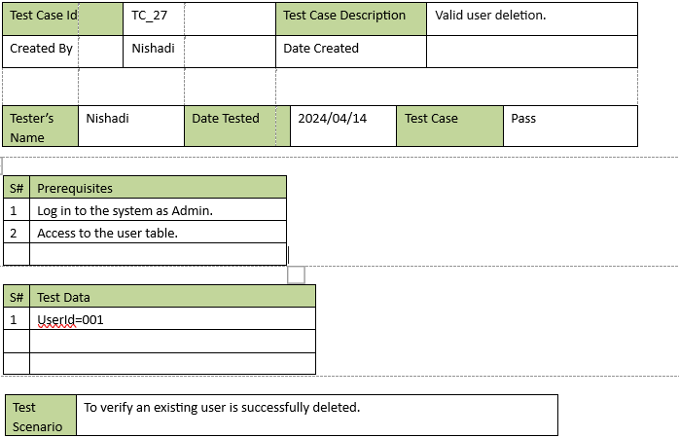

|  |  |  |  |  |  |  |  |  |  |  |
| --- | --- | --- | --- | --- | --- | --- | --- | --- | --- | --- |
| Test case ID | | | PM1 | | Test case Description | | Testing the Insert of all project details | | | |
| Created By | | | Manuji | | Date Created | | 29-March-2024 | | | |
|  | | | | | | | | | | |
| Tester’s Name | | | Manuji | | Date Tested | | 29-Mrach- 2024 | | Test Case | pass |
|  | | | | | | | | | | |
| S# | | Prerequisites | | | | S# | Test Data | | | |
| 1 | | Access to chrome Browser | | | | 1 | Project id =P001 | | | |
| 2 | | Login to the Tools management system | | | | 2 | Project name = EOT & Monorail cranes Manufacturing and installation | | | |
| 3 | | Access to the Manager Dashboard | | | | 3 | Description = Client: CCB Envico Pty Ltd-Australia. | | | |
|  | |  | | | | 4 | Site Supervisor id = SiteS001 | | | |
| 5 | Site Supervisor name =Saman Kumara | | | |
| 6 | Location id =L001 | | | |
| 7 | Location Name = Wastewater pump stations in Dehiwala, Mount Lavinia and Kolonnawa. | | | |
|  | |  | | | | 8 | Date =24th April 2024 | | | |
| Test Scenario | | Verify on system response entering valid project details(positive) | | | | | | | | |
|  | | | | | | | | | | |
| Step # | Step Details | | | Expected Results | | Actual Results | | Pass/Fail/Not  Executed/ Suspended | | |
| 1 | Navigate to [Tools management system.](http://www.dilumbmkengineers.com/) | | | Site should open | | As Expected | | Pass | | |
| 2 | Enter Project id, Project id, Project Name, Description, Site Supervisor, Site Supervisor name, Location id & Location name | | | Credential can be | | As Expected | | Pass | | |
| 3 | Click Submit button | | | Credential can be | | As Expected | | Pass | | |

|  |  |  |  |  |  |  |  |  |  |  |  |
| --- | --- | --- | --- | --- | --- | --- | --- | --- | --- | --- | --- |
| Test case ID | | | PM2 | | | Test case Description | | Testing the One filed is not added | | | |
| Created By | | | Manuji | | | Date Created | | 29-Mrach-2024 | | | |
|  | | | | | | | | | | | |
| Tester’s Name | | | | Manuji | | Date Tested | | 29-  March- 2024 | | Test Case | pass |
|  | | | | | | | | | | | |
| S# | | Prerequisites | | | | | S# | Test Data | | | |
| 1 | | Access to chrome Browser | | | | | 1 | Project id =P002 | | | |
| 2 | | Login to the Tools management system | | | | | 2 | Project name = Manufacturing and installation,2 over Head  travelling crane | | | |
| 3 | | Access to the Manager Dashboard | | | | | 3 | Description = Client: Squire Mech Engineers Pvt Ltd. | | | |
| 4 | | Access to the Project managing section | | | | | 4 | Site Supervisor id = SI002 | | | |
| 5 | Site Supervisor name  =Hemal Perera | | | |
| 6 | Location id =L002 | | | |
| 7 | Location Name = Wastewater pump stations in Dehiwala, Mount Lavinia and Kolonnawa. | | | |
|  | |  | | | | | 8 | Date = [empty] | | | |
| Test Scenario | | Verify system response when entering invalid project details(Negative) | | | | | | | | | |
|  | | | | | | | | | | | |
| Step # | Step Details | | | | Expected Results | | Actual Results | | Pass/Fail/Not Executed/ Suspended | | |
| 1 | Navigate to [Toolsmanagement system.](http://www.dilumbmkengineers.com/) | | | | Site should open | | As Expected | | Pass | | |
| 2 | Enter Project id, Project id, Project Name, Description, Site Supervisor, Site Supervisor name, Location id & Location name | | | | Credential can be. | | As Expected | | Pass | | |
| 3 | Click Submit button | | | | Display an error message “Please fill in all fields.”.”. | | As Expected | | Pass | | |
|  | | | | | | | | | | | |

|  |  |  |  |  |  |  |  |  |  |  |
| --- | --- | --- | --- | --- | --- | --- | --- | --- | --- | --- |
| Test case ID | | | PM3 | | Test case Description | | Testing the insert of Project  Id in invalid format. | | | |
| Created By | | | Manuji | | Date Created | | 29-Mrach-2024 | | | |
|  | | | | | | | | | | |
| Tester’s Name | | | Manuji | | Date Tested | | 29-  March- 2024 | | Test Case | pass |
|  | | | | | | | | | | |
| S# | | Prerequisites | | | | S# | Test Data | | | |
| 1 | | Access to chrome Browser | | | | 1 | Project id =kl67 | | | |
| 2 | | Login to the Tools management system | | | | 2 | Project name = All Mechanical Installation of  Water treatment plant & Intake. | | | |
| 3 | | Access to the Manager Dashboard | | | | 3 | Description = Client: Abeima | | | |
|  | |  | | | | 4 | Site Supervisor id = SI003 | | | |
| 5 | Site Supervisor name =prasad adikari | | | |
| 6 | Location id = L002 | | | |
| 7 | Location Name = Wastewater pump stations in Dehiwala, Mount Lavinia and Kolonnawa. | | | |
|  | |  | | | | 8 | Date = 6th of July 2024 | | | |
| Test Scenario | | Verify on system response when update by empty project details, | | | | | | | | |
|  | | | | | | | | | | |
| Step # | Step Details | | | Expected Results | | Actual Results | | Pass/Fail/Not Executed/ Suspended | | |
| 1 | Navigate to [Tools management system.](http://www.dilumbmkengineers.com/) | | | Site should open | | As Expected | | Pass | | |
| 2 | Enter Project id, Project id, Project Name, Description, Site Supervisor, Site Supervisor name, Location id & Location name | | | Credential can be. | | As Expected | | Pass | | |
| 3 | Click Submit button | | | Project ID must be in the format P001 | | As Expected | | Pass | | |

|  |  |  |  |  |  |  |  |  |  |  |
| --- | --- | --- | --- | --- | --- | --- | --- | --- | --- | --- |
| Test case ID | | | PM4 | | Test case Description | | Test the Creation of location details partially empty. | | | |
| Created By | | | Manuji | | Date Created | | 29-Mrach-2024 | | | |
|  | | | | | | | | | | |
| Tester’s Name | | | Manuji | | Date Tested | | 29-Mrach- 2024 | | Test Case | pass |
|  | | | | | | | | | | |
| S# | | Prerequisites | | | | S# | Test Data | | | |
| 1 | | Access to chrome Browser | | | | 1 | Project id =L003 | | | |
| 2 | | Login to the Tools management system | | | | 2 | Project name = [empty] | | | |
| 3 | | Access to the Manager Dashboard | | | |  |  | | | |
| Test Scenario | | Verify on Creation of location details partially empty. (Negative) | | | | | | | | |
|  | | | | | | | | | | |
| Step # | Step Details | | | Expected Results | | Actual Results | | Pass/Fail/Not  Executed/ Suspended | | |
| 1 | Navigate to https:/[/www.dilumbmkengineers.com](http://www.dilumbmkengineers.com/) | | | Site should open | | As Expected | | Pass | | |
| 2 | Enter Project id, Project id, Project Name, Description, Site Supervisor, Site Supervisor name, Location id & Location name | | | Credential can be. | | As Expected | | Pass | | |
| 3 | Click update button | | | Display an error message “All the fields should be flled” | | As Expected | | Pass | | |

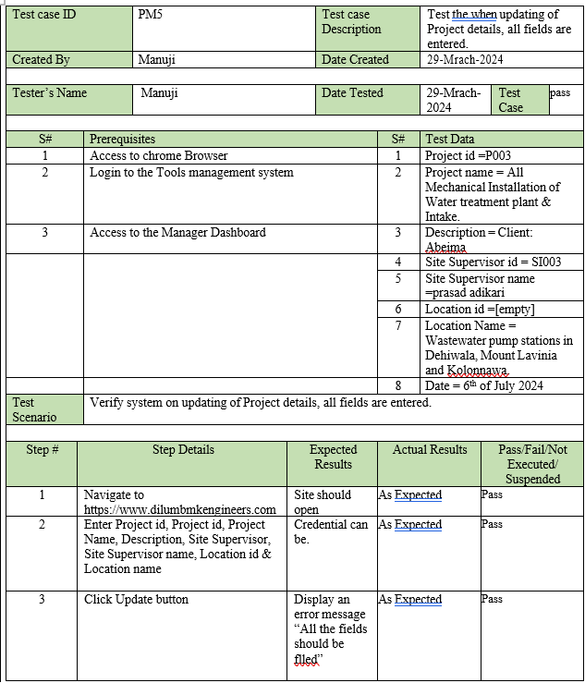

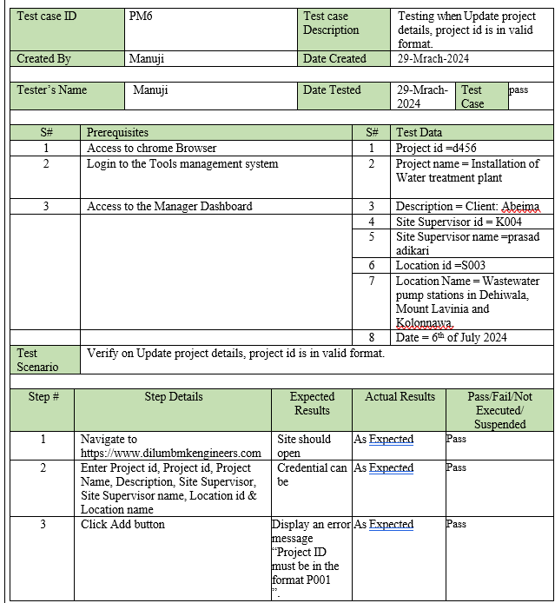

|  |  |  |  |  |  |  |  |  |  |  |
| --- | --- | --- | --- | --- | --- | --- | --- | --- | --- | --- |
| Test case ID | | | PM9 | | Test case Description | | Test the viewing of Project details | | | |
| Created By | | | Manuji | | Date Created | | 29-Mrach-2024 | | | |
|  | | | | | | | | | | |
| Tester’s Name | | | Manuji | | Date Tested | | 29-Mrach- 2024 | | Test Case | pass |
|  | | | | | | | | | | |
| S# | | Prerequisites | | | | S# | Test Data | | | |
| 1 | | Access to chrome Browser | | | | 1 | Project id =P011 | | | |
| 2 | | Login to the Tools management system | | | | 2 | Project name = All Mechanical Installation of Water treatment plant &  Intake. | | | |
| 3 | | Access to the Manager Dashboard | | | | 3 | Description = Client: Abeima | | | |
|  | |  | | | | 4 | Site Supervisor id = SiteS003 | | | |
| 5 | Site Supervisor name =prasad adikari | | | |
| 6 | Location id =L013 | | | |
| 7 | Location Name = Wastewater pump stations in Dehiwala, Mount Lavinia and Kolonnawa. | | | |
|  | |  | | | | 8 | Date = 6th of July 2024 | | | |
| Test Scenario | | Verify system should response when viewing project details by click the “manage project details” .(positive) | | | | | | | | |
|  | | | | | | | | | | |
| Step # | Step Details | | | Expected Results | | Actual Results | | Pass/Fail/Not Executed/ Suspended | | |
| 1 | Navigate to https:/[/www.dilumbmkengineers.com](http://www.dilumbmkengineers.com/) | | | Site should open | | As Expected | | Pass | | |
| 2 | Click “manage project details” button | | | Display project data | | As Expected | | Pass | | |

|  |  |  |  |  |  |  |  |  |  |  |
| --- | --- | --- | --- | --- | --- | --- | --- | --- | --- | --- |
| Test case ID | | | PM11 | | Test case Description | | Test the viewing of tools stock details | | | |
| Created By | | | Manuji | | Date Created | | 29-Mrach-2024 | | | |
|  | | | | | | | | | | |
| Tester’s Name | | | Manuji | | Date Tested | | 29-Mrach- 2024 | | Test Case | pass |
|  | | | | | | | | | | |
| S# | | Prerequisites | | | | S# | Test Data | | | |
| 1 | | Access to chrome Browser | | | | 1 | Tool_ID = AGM01 | | | |
| 2 | | Login to the Tools management system | | | | 2 | ToolName = Angle Grinder Machine - 4'' | | | |
| 3 | | Access to the Manager Dashboard | | | | 3 | Description = weight 50kg | | | |
|  | |  | | | | 4 | Quantity =12 | | | |
| Test Scenario | | Verify system should response when click “tools stock details” on the navigation bar, viewing of tools stock details(positive) | | | | | | | | |
|  | | | | | | | | | | |
| Step # | Step Details | | | Expected Results | | Actual Results | | Pass/Fail/Not Executed/ Suspended | | |
| 1 | Navigate to https:/[/www.dilumbmkengineers.com](http://www.dilumbmkengineers.com/) | | | Site should open | | As Expected | | Pass | | |
| 2 | Click “tools stock details”button on the navigation bar | | | Display tools stock details | | As Expected | | Pass | | |

# 2. Other Nonfunctional Requirements

## a. Performance Requirements

Performance is a crucial characteristic that characterized how the system response to different user inputs. The system performance considered under these factors,

* Response Time
* Scalability
* Data Integrity
* Cross-Platform Compatibility

|  |  |
| --- | --- |
| Name | Description |
| Page Loading Time | The page loading time should be within 4-8 seconds. |
| Scalability | The system should be able to handle an increasing number of users, equipment’s and projects without significant degradation in performance. |
| Data Integrity | The system should ensure the integrity of data by implementing mechanisms such as data validation, error handling, and transaction management to prevent corruption or loss of information. |
| Cross-Platform Compatibility | The web application should be compatible with web browsers such as Chrome, Mozilla Firefox |

## b. Safety Requirements

* Every user needs to have a separate user account with their own user credentials to log in to this system. Users can log out from their account once they are done with their work or leaving the workspace to protect the system from unauthorized access.

* Generate confirmation messages: all edit/save/reset/delete/remove functions should be confirmed before the action.

* Data loss or system failure: the system should take the backups of the user database regularly.

## c. Security Requirements

* To secure user and company tools information, the system should emphasize strong security measures. Secure data transmission, encryption of sensitive data and role base action are all part of this.

* Only users with valid login credentials can access the system.

* The system must use strong encryption to protect users’ personal information and company information.

## d. Software Quality Attributes

###### Reliability

The system should be reliable in managing tools information accurately, e ensuring that the data regarding inventory, tools status, and project details are dependable for decision making processes.

###### Usability

The web application should be user friendly for all stakeholders, including Admin, managers, stock supervisors and site supervisors involves an intuitive interface, easy navigation, and clear instructions for tasks such as adding tools, managing projects, and generating reports.

###### Flexibility

Error messages are displayed to the user for invalid operations within functions or any valid login attempt.

###### Performance

The system should perform efficiently, especially considering the large amounts of data it will handle regarding tool inventory, project details, and user accounts. Quick response time and minimal downtime are crucial for smooth operations.

###### Security

As application deals with sensitive information such as user accounts, project details, and tools inventory, robust security measures should be in place to protect against unauthorized access and ensure the integrity of the system.

###### Interoperability

The application should be able to seamlessly integrate with other systems or tools that the company may use for related process such as QR scanning, or inventory management, facilitating smooth communication and data exchange between different platforms.

###### Accuracy

The system should ensure the accuracy of information regarding tools details, project assignments, and inventory levels, as any discrepancies or errors could lead to inefficiencies or disruptions in operations.

## e. Business Rules

###### User Authentication

* Only admin can manage user accounts.
* Company Managers can manage project details and assign site supervisors.
* Only Stock supervisor can manage tool inventory.
* Both managers and stock supervisors can view toolboxes full details entering toolbox Id.

###### Role-Based access control

- Each user role has specific permissions and access levels within the system.

Ex: Admins have full access to user management features, while Stock supervisors can only manage tool inventory-related functions.

###### Project Management

- Managers have exclusive rights to manage projects details, including assigning site supervisors and overseeing tool usage and inventory allocation for each project.

###### Inventory Management

- Stock supervisors are responsible for managing tool information, managing inventory levels, view toolboxes full details entering toolbox Id, and view reports of required tools reports.

###### Tool assignment and reporting

- Site supervisors can assign tools to own specific projects, send tool reports to Stock supervisors, conform toolbox usage. And upload tool status reports.

# 3. Other Requirements

According to the client requirements, every necessary condition is covered in the SRS document. Then there is no other requirement.